KENDRIYA VIDYALAYA NO.2
ITANAGAR, ARUNACHAL PRADESH


A PROJECT REPORT ON
BAKERY MANAGEMENT SYSTEM

KENDRIYA VIDYALAYA NO.2

Submitted to submitted by:
mr. S K MISRA KESHAB CHETRY
p.g.t.(comp. sc) CLASS:12A ROLL NO.:18

  - CERTIFICATE

This is to certify that KESHAB CHETRY of class: XII A of KENDRIYA VIDYALAYA NO.2 has done his project on BAKERY MANAGEMENT SYSTEM under my supervision. He has taken interest and has shown at most sincerity in completion of this project.
I certify this Project up to my expectation & as per guidelines issued by CBSE, NEW DELHI.

Internal Examiner External Examiner

Principal

ACKNOWLEDGMENT

It is with pleasure that I acknowledge my sincere gratitude to our teacher, MR. S K MISRA who taught and undertook the responsibility of teaching the subject computer science. I have been greatly benefited from his classes.
I am especially indebted to our Principal MR. K R MEENA who has always been a source of encouragement and support and without whose inspiration this project would not have been a successful I would like to place on record heartfelt thanks to him.
Finally, I would like to express my sincere appreciation for all the other students for my batch their friendship & the fine times that we all shared together.

Hardware and software REQUired
HARDWARE

- pc
- Mobile PHONE

SOFTWARE

- PYTHON 3.10.2
- MySQL
- Python connector

CODING
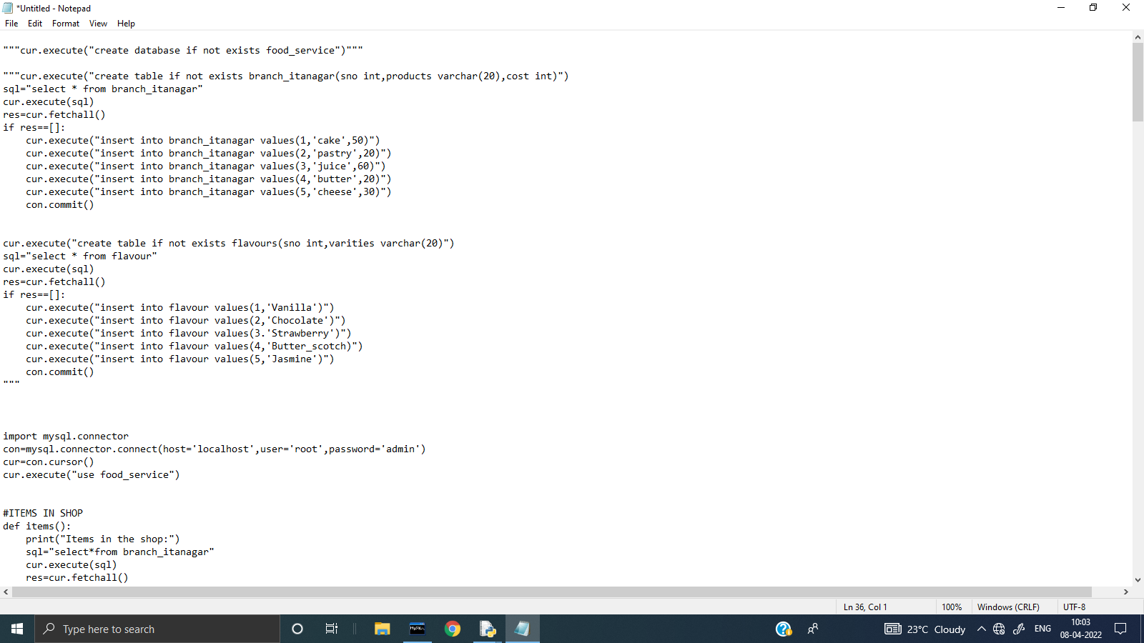
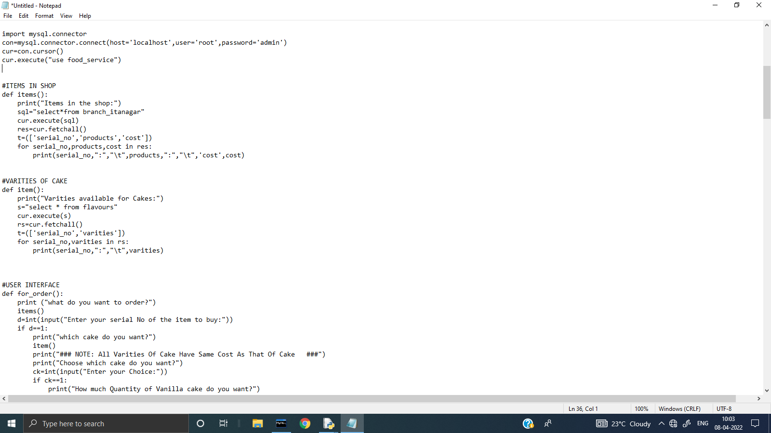
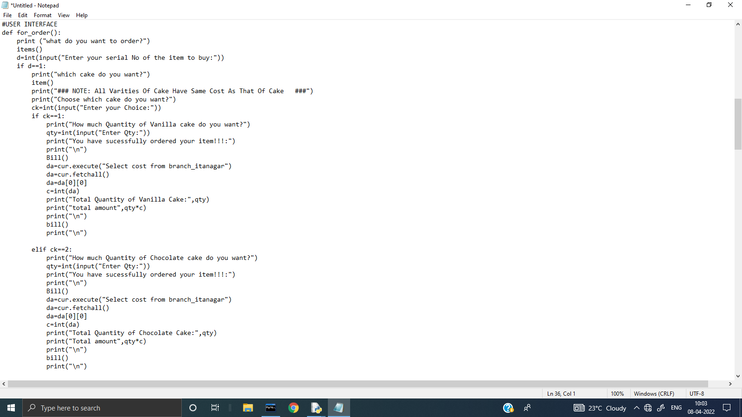
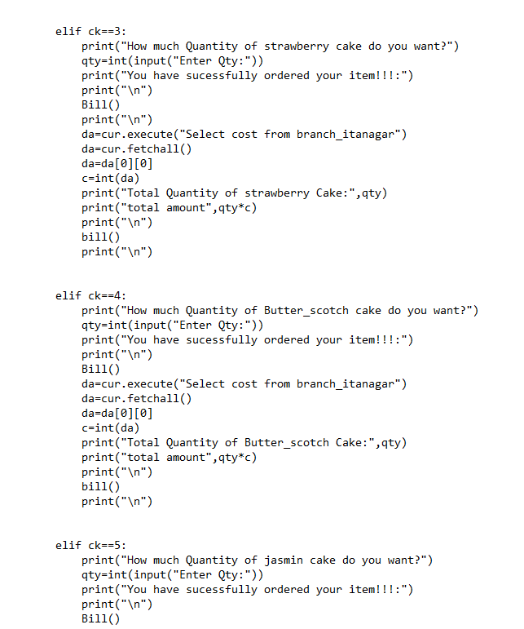

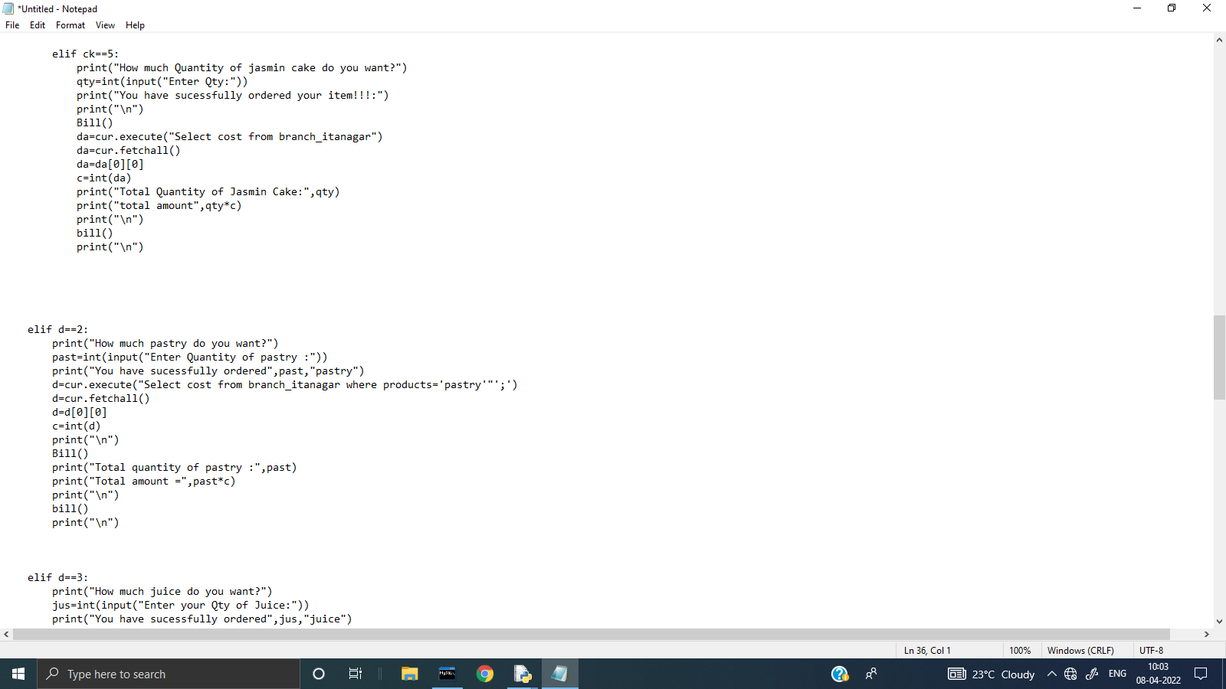

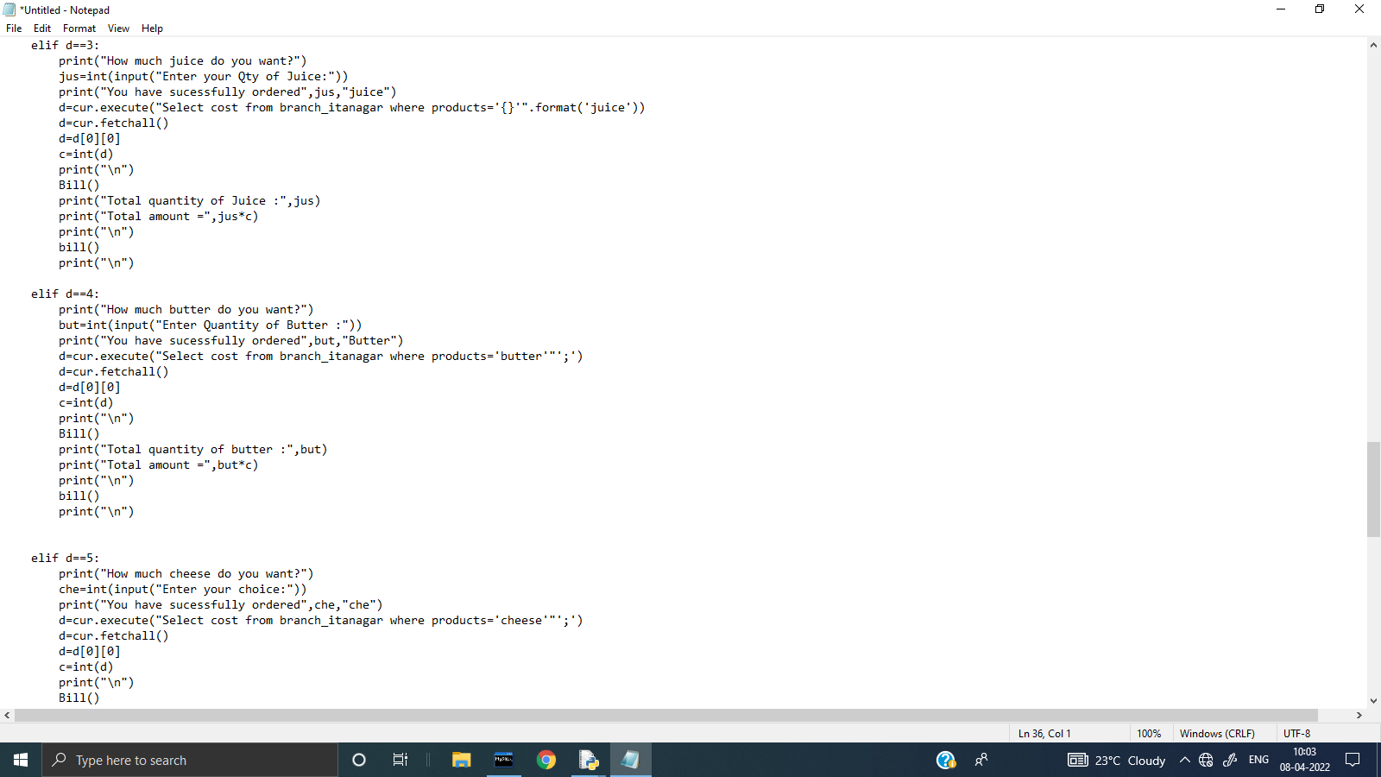
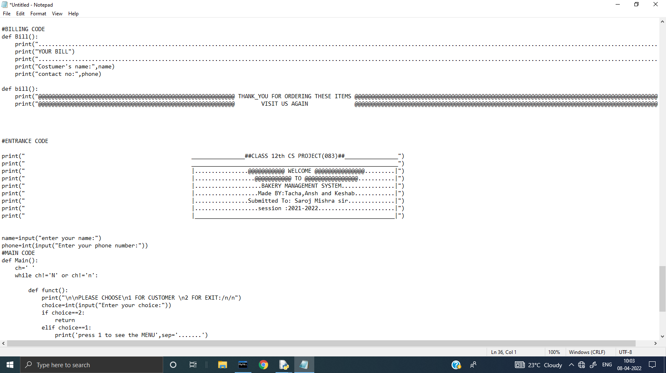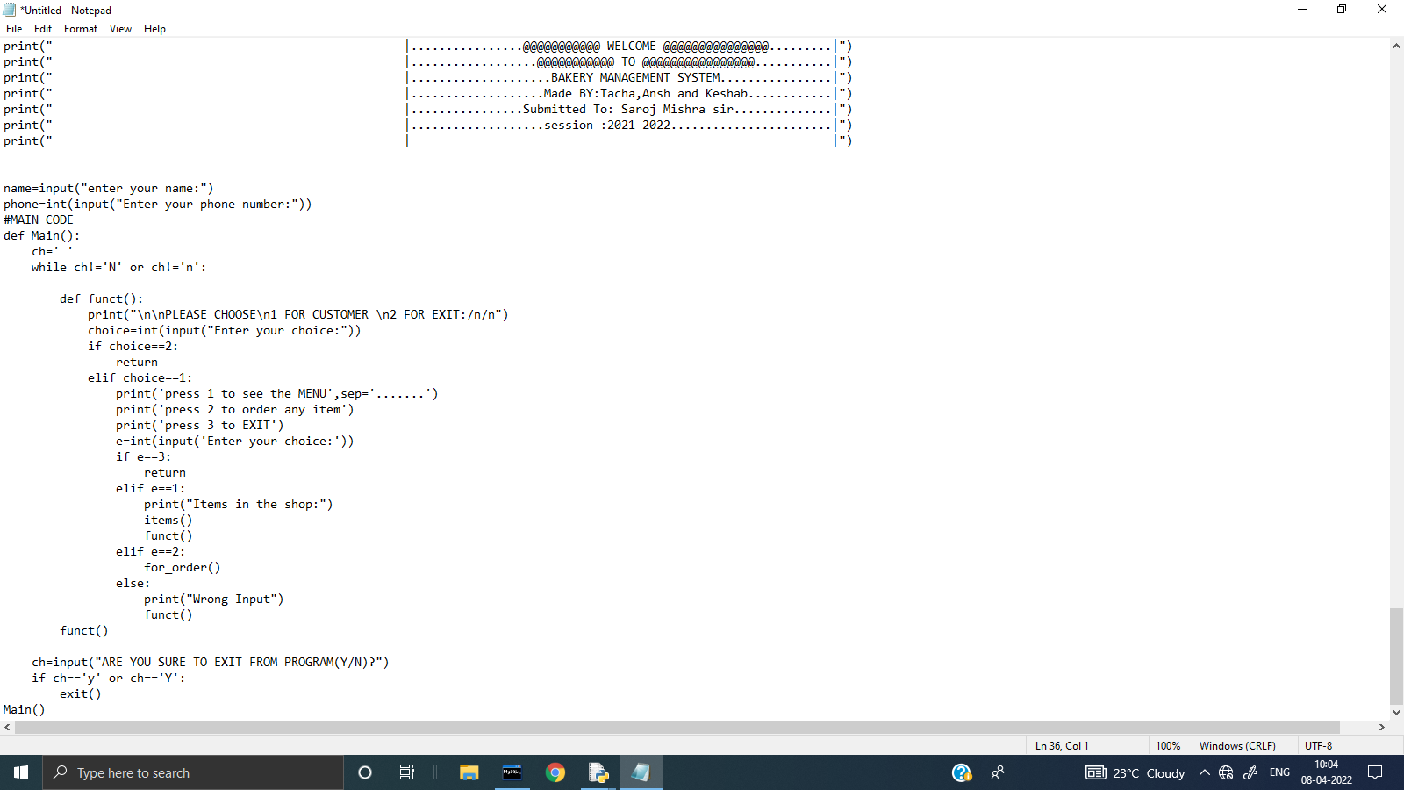
SQL TABLE
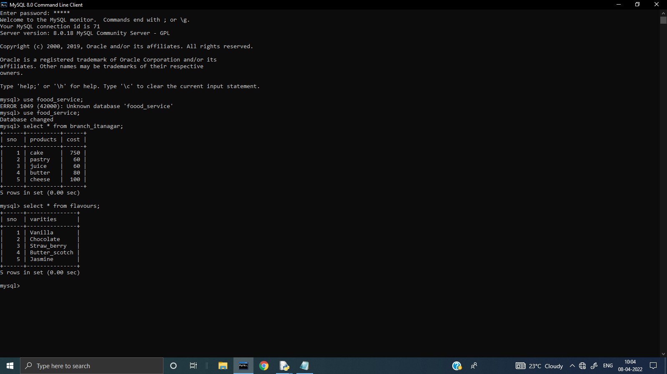
OUTPUT
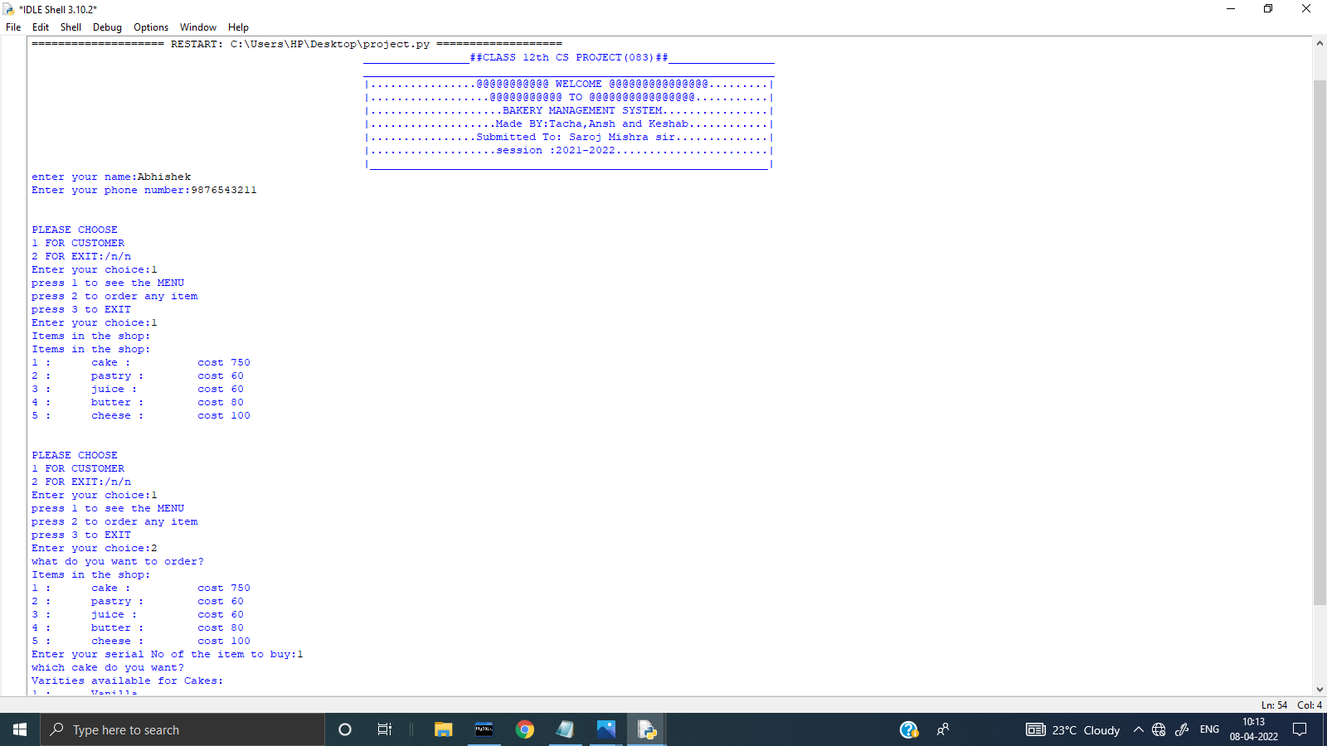
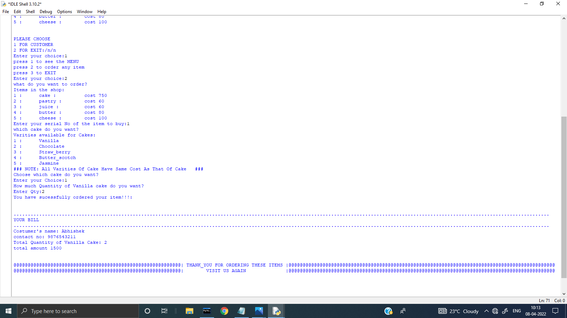
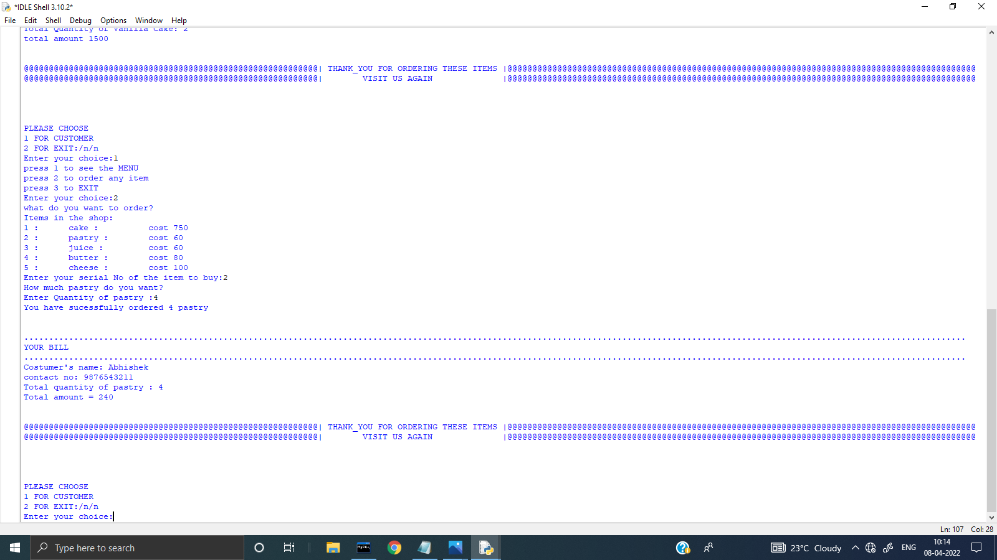
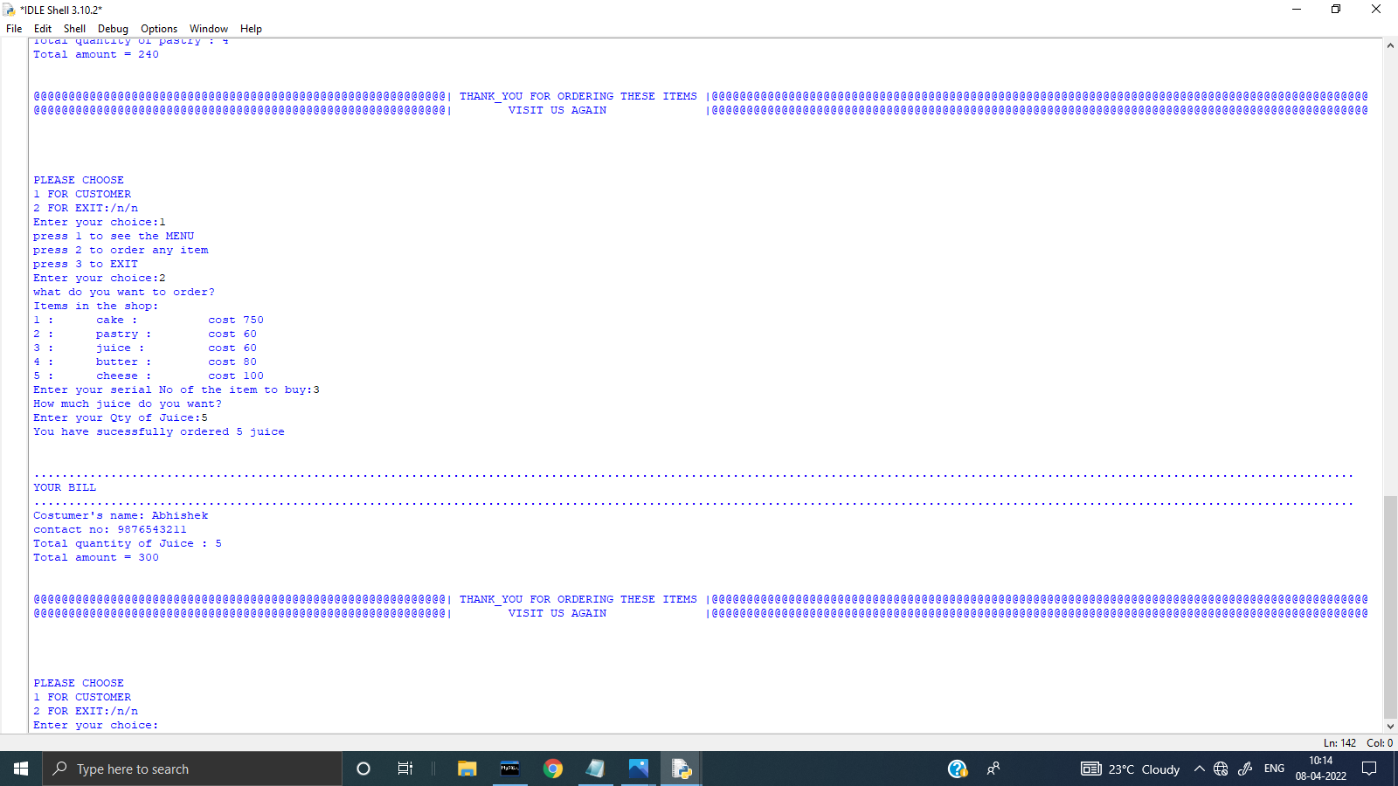
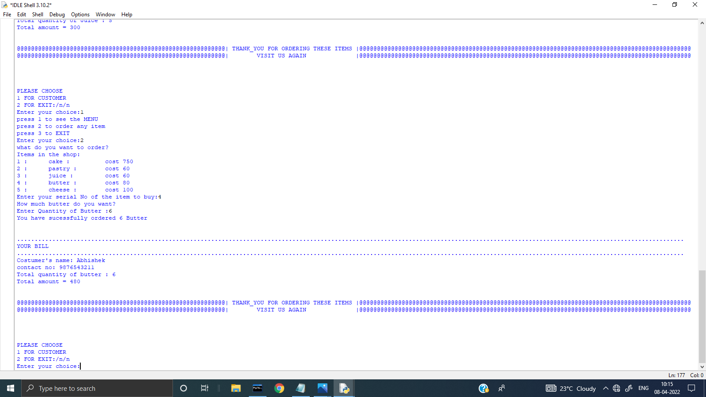
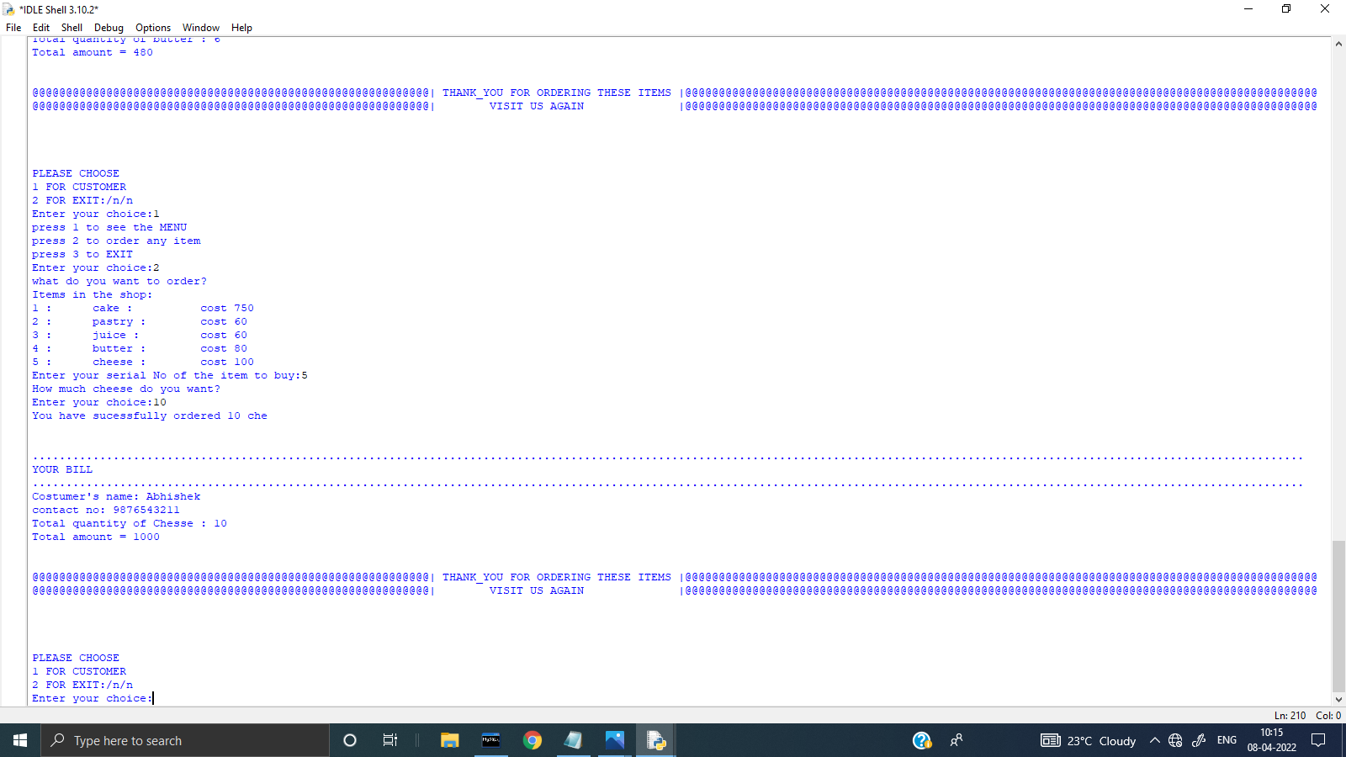

BIBLIOGRAPHY

1.WWW.SCRIBD.COM
2.WWW.WIKIPEDIA.COM
3.WWW.GOOGLE.COM
4.CLASS 12 NCERT BOOK BY SUMITA ARORA

