PM SHRI KENDRIYA VIDYALAYA

BERHAMPUR

SESSION 2024-25

A Project Report on
LogicLeaf : BANK MANAGEMENT SYSTEM

For CBSE 2025 AISSCE
[As a part of the Computer Science Course (083)]

SUBMITTED BY: SUBMITTED TO:
PRITAM KUMAR PARAMAGURU Mr. S.K. MISRA
Class: XII ‘A’ (PGT)
Board Roll no: 12645170 (Computer Science)

ACKNOWLEDGEMENT

I warmly acknowledge the continuous encouragement and timely suggestions offered by our Principal Mr. SHIVAPRIYA DASH. I extend my hearty thanks for giving me the opportunity to make use of facilities available in the campus to carry out the project successfully.

I am highly indebted to Mr. SAROJ KANTA MISRA, (PGT Computer Science), for the constant supervision, providing necessary information and supporting in completing the project. I would like to express my gratitude towards him for his kind cooperation and encouragement.

Finally, I extend my gratefulness to one and all who are directly or indirectly involved in the successful completion of this project.

CERTIFICATE

THIS IS TO CERTIFY THAT PRITAM KUMAR PARAMAGURU STUDYING IN CLASS XII A, HAS SATISFACTORILY COMPLETED PROJECT WITH THE TITLE (LogicLeaf : Bank Management System) UNDER THE GUIDANCE OF MR. SAROJ KANTA MISRA, PGT (Computer Science) DURING THE ACADEMIC SESSION 2024-25 IN PARTIAL FULFILLMENT OF “COMPUTER SCIENCE PRACTICAL EXAMINATION OF CENTRAL BOARD OF SECONDARY EDUCATION (CBSE)”.

INTERNAL EXAMINER EXTERNAL EXAMINER

PRINCIPAL

TABLE OF CONTENTS

- Introduction

- System Implementation

  - The Hardware

  - The Software

- System Design & Development

  - Python Coding (i.e. Source Code)

  - Database

  - Output Screen

- References

INTRODUCTION
Welcome to LogicLeaf's Bank Management System – Redefining Financial Excellence
In the fast-evolving world of finance, efficiency, security, and adaptability are non-negotiable. LogicLeaf's Bank Management System (BMS) is designed to revolutionize banking operations by blending cutting-edge technology with seamless functionality.
Imagine a system that effortlessly manages customer accounts, transactions, loans, and investments while ensuring robust security and compliance with global financial standards. LogicLeaf BMS is your comprehensive solution, offering:
- User-friendly Interfaces: Simplified navigation for staff and customers.
- Advanced Analytics: Gain actionable insights to drive strategic growth.
- 24/7 Accessibility: Ensure uninterrupted services, anytime, anywhere.
- Tailored Solutions: Adaptable features to suit the unique needs of every financial institution.
With LogicLeaf, experience the future of banking today. Trust us to transform traditional banking into a streamlined, modern experience. Let's innovate together.
LogicLeaf – Growing Smarter Banking Solutions.

LogicLeaf
LogicLeaf: Growing Ideas with Python and Cutting-Edge Programming
At LogicLeaf, we believe in the transformative power of programming to shape the future of technology. With Python as our cornerstone, we craft solutions that are robust, efficient, and endlessly versatile. Just as a leaf grows to harness energy, LogicLeaf evolves programming ideas into powerful, impactful systems.

What We Do in Programming
At LogicLeaf, we take pride in being your go-to partner for programming innovation. Our expertise includes:
- Python Development: From scripting automation to full-stack web applications, our Python developers are second to none.
- AI and Machine Learning: Empower your systems with intelligent algorithms for smarter decision-making and deeper insights.
- Web Development: Using frameworks like Django and Flask, we create dynamic, scalable websites and APIs.
- Data Engineering: Build pipelines that handle big data efficiently and deliver actionable insights.
- Automation and Scripting: Optimize your workflows with custom scripts that simplify complex tasks.
- Game Development: Develop immersive games using Python libraries like Pygame.
- API Development and Integration: Seamlessly connect your services with robust APIs.

Our Programming Toolkit
While Python is our flagship, LogicLeaf boasts expertise in a wide range of programming technologies, including:
- JavaScript Frameworks: React, Angular, and Node.js for building responsive front- and back-end systems.
- Cloud Integration: AWS, Google Cloud, and Azure for scalable, secure deployments.
- Database Solutions: PostgreSQL, MySQL, MongoDB, and more for efficient data handling.
- DevOps and CI/CD Pipelines: Streamlined development workflows with tools like Docker and Jenkins.

Why Choose LogicLeaf for Python and Programming?
- Expert Coders: Our developers bring years of experience and a passion for clean, efficient code.
- Tailored Solutions: We don’t believe in one-size-fits-all. Every project is uniquely crafted to suit your needs.
- Innovative Edge: With Python and cutting-edge tools, we deliver future-proof solutions.
- Collaborative Approach: Your vision is our blueprint—we work closely with you every step of the way.

Our Vision in Programming
To revolutionize the digital landscape by delivering programming solutions that are smart, scalable, and sustainable.

Our Mission in Python
To harness the power of Python to simplify complexities, drive innovation, and deliver excellence in every project.
LogicLeaf – Rooted in Python, Growing the Future of Programming.

Python
Python is a versatile and widely used programming language with features that make it a favorite among beginners and professionals alike. Here’s why Python stands out:
- Simplicity and Readability:
  - Python’s clean syntax emphasizes readability, making it easy to learn and write.
  - Ideal for beginners, as the code structure is intuitive and less complex than many other languages.
- Wide Range of Applications:
  - Used in web development, data science, artificial intelligence, machine learning, automation, and game development.
  - Supports a variety of domains with specialized libraries like Django, NumPy, Pandas, and TensorFlow.
- Flexibility in Programming Paradigms:
  - Allows procedural, object-oriented, and functional programming, catering to diverse problem-solving approaches.
- Extensive Library and Community Support:
  - Comes with a robust standard library, reducing the need to write code from scratch for many tasks.
  - Backed by a large and active community, ensuring continuous updates, resources, and troubleshooting assistance.
- Efficiency and Productivity:
  - Speeds up development with features like dynamic typing and automatic memory management.
  - Facilitates rapid prototyping and efficient handling of complex tasks.
SYSTEM IMPLEMENTATION

HARDWARE:
- PC
Processor: Intel Pentium G3240
RAM: 4.00 GB

- LAPTOP
Processor: 11th Gen Intel(R) Core(TM) i3-1115G4 @ 3.00GHz 3.00 GHz
RAM: 8.00 GB

SOFTWARE:
- OPERATING SYSTEM
Windows 11

- PYTHON IDLE
Python 3.13.1

- MySQL
- MySQL-Connector-Python, Webbrowser, Datetime, Calender, Tabulate

import mysql.connector as ms
from random import randint
import datetime as dt
import calendar as c
from tabulate import tabulate
import webbrowser

#-----------DATA VALIDITY SECTION STARTS HERE-----------

#TO CHECK THE VALIDITY OF GIVEN CONTACT NUMBER

def phnocheck(ph):
if len(str(ph))!=10 or ph<0:
print("!!!!!!!Enter a valid contact number!!!!!!!")
return True
if ph>2147483647:
print("!!!!!!!sql error: Enter a contact number
smaller than 2147483647!!!!!!!")
return True
return False

#TO CHECK THE VALIDITY OF GIVEN EMAIL

def emailcheck(em):
if not (em.split(".")[-1].isalpha()) or em.count("@")!=1:
print("!!!!!!!Invalid email!!!!!!!")
return True
if len(em)>30:
print("!!!!!!!Email is too long!!!!!!!")
return True
for i in em:
if not(i.isalnum() or i=="@" or i=="."):
print("!!!!!!!Invalid email!!!!!!!")
return True
return False

#TO CHECK THE VALIDITY OF GIVEN DATE

def datecheck(date):
l=date.split("-")
if len(l)!=3 or len(date)!=10 or len(l[0])!=4 or
len(l[1])!=2 or len(l[2])!=2 :
print("!!!!!!!Please enter date in the format yyyy-
mm-dd!!!!!!!")
return True
if not(l[0].isdigit()) or not(l[1].isdigit()) or
not(l[2].isdigit()):
print("!!!!!!!Please enter a valid date in the format
yyyy-mm-dd!!!!!!!")
return True
if (int(l[1]) in [1,3,5,7,8,10,12] and int(l[2])>31) or
(int(l[1]) in [4,6,9,11] and int(l[2])>30):
print("!!!!!!!Please enter a valid date!!!!!!!")
return True
elif int(l[1])==2:
if ((int(l[0])%4==0 and int(l[0])%100!=0) or
(int(l[0])%400==0)):
if int(l[2])>29:
print("!!!!!!!Please enter a valid
date!!!!!!!")
return True
elif int(l[2])>28:
print("!!!!!!!Please enter a valid date!!!!!!!")
return True
return False

#-----------DATA VALIDITY SECTION ENDS HERE-----------

#-------------LOGIN INTERFACE STARTS HERE-------------

def interface():
print("*******WELCOME TO BANK MANAGEMENT SYSTEM*******")
ut=input("Enter login type(admin or customer) or (exit):")
if ut=="admin":
adminlogin()
elif ut=="customer":
customerlogin()
elif ut=="exit":
print("-----------------------------------------------
-")
print("*******...THANK YOU,PLEASE VISIT
AGAIN...*******")
print("-----------------------------------------------
-")
else:
print("!!!!!!!Enter admin or customer or exit
only!!!!!!!")
interface()

#----------LOGIN INTERFACE ENDS HERE-----------

#--------CUSTOMER INTERFACE STARTS HERE--------

def customerlogin():
db=ms.connect(host="localhost",user="root",password=admin,
database="bms")
cb=db.cursor()
cb.execute("select id,password from interface where
type='{}'".format("user"))
u=cb.fetchall()
print("*******WELCOME TO USER INTERFACE*******")
id=input("Enter login id:")
pd=input("Enter your password:")
for i in u:
if i[0]==id and i[1]==pd:
cb.execute("select Account_number from
acc_details where id='{}'"
.format(id))
u=cb.fetchone()
ac=u[0]
print("~~~~~~~LOGIN SUCCESSFUL~~~~~~~")
cust_home(ac)
break
else:
print("!!!!!!!INVALID CREDENTIALS!!!!!!!")
print("!!!!!!!AUTHENTICATION UNSUCCESSFUL!!!!!!!")
print("#######ACCESS DENIED#######")

#TO DISPLAY CUSTOMER PANEL

def cust_home(ac):
print("_______CUSTOMER PANEL_______")
print("Enter mp to modify id and password")
print("Enter a for account details")
print("Enter ab to check available balance")
print("Enter l for locker details")
print("Enter p to create or modify pin")
print("Enter t for transaction panel")
print("Enter th to see transaction history")
print("Enter r for review")
print("Enter lo to log out")
ch=input("Enter your choice:")
if ch=="mp":
modifypassword()
elif ch=="a":
acc(ac)
elif ch=="ab":
balance(ac)
elif ch=="l":
locker(ac)
elif ch=="p":
transpin(ac)
elif ch=="t":
transac(ac)
elif ch=="th":
transhis(ac)
elif ch=="r":
review(ac)
elif ch=="lo":
interface()
else:
print("!!!!!!!Enter mp or a or ab or l or p or t or th
or r or lo only!!!!!!!")
cust_home(ac)

#TO MODIFY LOGIN PASSWORD

def modifypassword():
db=ms.connect(host="localhost",user="root",password=admin,
database="bms")
cb=db.cursor()
print("_______MODIFY PASSWORD PANEL_______")
cb.execute("select * from interface where
Type={}".format("user"))
u=cb.fetchall()
op=input("Enter old password:")
if(len(op))<8:
print("!!!!!!!Entered value is too short!!!!!!!")
modifypassword()
return
elif (len(op))>8:
print("!!!!!!!Entered value is too long!!!!!!!")
modifypassword()
return
for i in u:
if op==i[1]:
np=input("Enter new password:")
if(len(np))<8:
print("!!!!!!!Entered value is too
short!!!!!!!")
modifypassword()
return
elif (len(np))>8:
print("!!!!!!!Entered value is too
long!!!!!!!")
modifypassword()
return
else:
cb.execute("update interface set password={} where
password={}".format(np,op))
db.commit()
print("~~~~~~~PASSWORD MODIFIED
SUCCESSFULLY~~~~~~~")
leave("customer")
else:
print("!!!!!!!INVALID PASSWORD!!!!!!!")
print("!!!!!!!AUTHENTICATION UNSUCCESSFUL!!!!!!!")
print("#######ACCESS DENIED#######")

#TO DISPLAY ACCOUNT DETAILS OF THE CUSTOMER IN TABULAR FORM

def acc(ac):
db=ms.connect(host="localhost",user="root",password=admin,
database="bms")
cb=db.cursor()
cb.execute("select
Account_number,Account_holder,Nominee_name,Father_name,Date_of_birth,Gender,Marital_status,Contact_number,E_mail,Address,Account_type,Account_category from acc_details where Account_number={}".format(ac))
u=cb.fetchone()
if u:
print("_______ACCOUNT DETAILS_______")
acc=tabulate([u],headers=["Account_number","Account_holder","Nominee_name","Father_name","Date_of_birth","Gender","Marital_status","Contact_number","E_mail","Address","Account_type","Account_category"],tablefmt="grid")
print(acc)
cust_home(ac)

#TO DISPLAY BALANCE OF THE CUSTOMER IN TABULAR FORM

def balance(ac):
db=ms.connect(host="localhost",user="root",password=admin,
database="bms")
cb=db.cursor()
try:
pin=int(input("Enter your pin:"))
if (len(str(pin)))<4:
print("!!!!!!!Entered value is too short!!!!!!!")
print("!!!!!!!Enter pin of 4 digits!!!!!!!")
balance(ac)
elif(len(str(pin)))>4:
print("!!!!!!!Entered value is too long!!!!!!!")
print("!!!!!!!Enter pin of 4 digits!!!!!!!")
balance(ac)
except ValueError:
print("!!!!!!!Enter integer only!!!!!!!")
balance(ac)
cb.execute("select Pin from acc_details where
Account_number={}".format(ac))
ucb=cb.fetchone()
if ucb[0]==pin:
cb.execute("select * from acc_details natural join
avail_balance")
u=cb.fetchone()
print("_______AVAILABLE BALANCE_______")
bl=[]
if u[12]<2000:
print("!!!!!!!LOW BALANCE!!!!!!!")
else:
bl.append([u[0],u[1],int(u[14])])
balance=tabulate(bl,headers=["Account_number","Account_holder","Available_balance"],tablefmt="grid")
print(balance)
else:
print("!!!!!!!INVALID PIN!!!!!!!")
print("!!!!!!!AUTHENTICATION UNSUCCESSFUL!!!!!!!")
print("#######ACCESS DENIED#######")
cust_home(ac)

#TO DISPLAY LOCKER PANEL

def locker(ac):
print("_______LOCKER PANEL_______")
print("Enter mdl for more details about locker")
print("Enter la for your locker access")
print("Enter b to go back")
ch=input("Enter your choice:")
if ch=="mdl":
about_locker(ac)
elif ch=="la":
locker_access(ac)
elif ch=="b":
cust_home(ac)
else:
print("!!!!!!!Enter mdl or la or b only!!!!!!!")
locker(ac)

#TO DISPLAY MORE DETAILS ABOUT LOCKER

def about_locker(ac):
db=ms.connect(host="localhost",user="root",password=admin,
database="bms")
cb=db.cursor()
cb.execute("select Size,Registration_fee,Annual_rent from
locker")
u=cb.fetchall()
al=[]
for i in u:
al.append(i)
tal=tabulate(al,headers=["Size","Registration_fee","Annual_
rent"],tablefmt="grid")
print("_______MORE DETAILS ABOUT LOCKER_______")
print(tal)
print("***Note: Locker Visit Charges(All Sizes): 12 visits
free. Thereafter: Rs.100/- per visit.")
locker(ac)

#TO DISPLAY LOCKER DETAILS OF THE CUSTOMER IN TABULAR FORM

def locker_access(ac):
db=ms.connect(host="localhost",user="root",password=admin,
database="bms")
cb=db.cursor()
print("_______LOCKER ACCESS PANEL_______")
id=input("Enter your locker ID:")
if(len(id))<5:
print("!!!!!!!Entered value is too short!!!!!!!")
locker_access(ac)
elif (len(id))>5:
print("!!!!!!!Entered value is too long!!!!!!!")
locker_access(ac)
try:
lpin=int(input("Enter your pin:"))
if (len(str(lpin)))<4:
print("!!!!!!!Entered value is too
short!!!!!!!")
print("!!!!!!!Enter pin of 4 digits!!!!!!!")
locker_access(ac)
elif(len(str(lpin)))>4:
print("!!!!!!!Entered value is too long!!!!!!!")
print("!!!!!!!Enter pin of 4 digits!!!!!!!")
locker_access(ac)
except ValueError:
print("!!!!!!!Enter integer only!!!!!!!")
locker_access(ac)
cb.execute("select Locker_ID,Locker_Pin from locker where
Status='{}'".format("Rented"))
u=cb.fetchall()
c=0
for i in u:
if i[0]=="id" and i[1]=="lpin":
c=c+1
timestamp=dt.datetime.now().strftime("%Y-%m-%d
%H:%M:%S")
if c>12:
cb.execute("select Available_balance from
avail_balance where
Account_number={}".format(ac))
uu=cb.fetchone()
if uu[0]>=(100+2000):
cb.execute("update avail_balance set
Available_balance=Available_
balance-{} where
Account_number={}"
.format(100,ac))
cb.execute("select Nominee_name,Details
from locker where Locker_ID='{}'
and Locker_Pin={}".
format(id,lpin))
uc=cb.fetchone()
if uc:
lk=[]
for i in uc:
lk.append(i)
lkt=tablate(lk,headers=["Nominee_name",
"Details"],
tablefmt="grid")
print("_______LOCKER DETAILS_______")
print(lkt)
cb.execute("update locker set Access
log='{}' where Locker_ID='{}'"
.format(timestamp,id))
db.commit()
locker(ac)
else:
print("!!!!!!!YOU DON'T HAVE ENOUGH
BALANCE!!!!!!!")
print("#######ACCESS DENIED#######")
else:
cb.execute("select Nominee_name,Details from
locker where Locker_ID='{}' and
Locker_Pin={}".format(id,lpin))
uc=cb.fetchone()
if uc:
lk=[]
for i in uc:
lk.append(i)
lkt=tablate(lk,headers=["Nominee_name","
Details"],
tablefmt="grid")
print("_______LOCKER DETAILS_______")
print(lkt)
cb.execute("update locker set Access
log='{}' where Locker_ID='{}'".
format(timestamp,id))
db.commit()
locker(ac)
else:
print("!!!!!!!INVALID CREDENTIALS!!!!!!!")
print("!!!!!!!AUTHENTICATION
UNSUCCESSFUL!!!!!!!")
print("#######ACCESS DENIED#######")
#TO CREATE AND MODIFY TRANSACTION PIN OF THE CUSTOMER
def transpin(ac):
db=ms.connect(host="localhost",user="root",password=admin,da
tabase="bms")
cb=db.cursor()
print("Enter cp to create pin")
print("Enter mp to modify pin")
print("Enter b to go back")
ch=input("Enter your choice:")
if ch=="cp":
try:
np=int(input("Enter new pin:"))
if (len(str(np)))<4:
print("!!!!!!!Pin is too short!!!!!!!")
transpin(ac)
elif (len(str(np)))>4:
print("!!!!!!!Pin is too long!!!!!!!")
transpin(ac)
cb.execute("select Pin from acc_details")
u=cb.fetchall()
for i in u:
if np==i[0]:
break
else:
cb.execute("update acc_details set Pin={} where
Account_number={}".format(np,ac))
db.commit()
print("~~~~~~~PIN CREATED SUCCESSFULLY~~~~~~~")
leave("customer")
except ValueError:
print("!!!!!!!Enter integers only!!!!!!!")
transpin(ac)
elif ch=="mp":
try:
op=int(input("Enter your old pin:"))
if (len(str(op)))<4:
print("!!!!!!!Pin is too short!!!!!!!")
transpin(ac)
elif (len(str(op)))>4:
print("!!!!!!!Pin is too long!!!!!!!")
transpin(ac)
except ValueError:
print("!!!!!!!Enter integers only!!!!!!!")
transpin(ac)
cb.execute("select Pin from acc_details where
Account_number={}".format(ac))
u=cb.fetchone()
if u[1]==op:
try:
np=int(input("Enter new pin:"))
if (len(str(np)))<4:
print("!!!!!!!Pin is too short!!!!!!!")
transpin(ac)
elif (len(str(np)))>4:
print("!!!!!!!Pin is too long!!!!!!!")
transpin(ac)
for i in u:
if np==i[1]:
break
else:
cb.execute("update acc_details set Pin={}
where Account_number={}"
.format(np,ac))
db.commit()
print("~~~~~~~PIN MODIFIED
SUCCESSFULLY~~~~~~~")
leave("customer")
except ValueError:
print("!!!!!!!Enter integers only!!!!!!!")
transpin(ac)
else:
print("!!!!!!!INVALID PIN!!!!!!!")
print("!!!!!!!AUTHENTICATION UNSUCCESSFUL!!!!!!!")
print("#######ACCESS DENIED#######")
elif ch=="b":
cust_home(ac)
else:
print("!!!!!!!Enter cp or mp or b only!!!!!!!")
transpin(ac)

#TO DISPLAY TRANSACTION PANEL

def transac(ac):
print("_______TRANSACTION PANEL_______")
print("Enter d to debit money")
print("Enter c to credit money")
print("Enter b to go back")
ch=input("Enter your choice:")
if ch=="d":
debit(ac)
elif ch=="c":
credit(ac)
elif ch=="b":
cust_home(ac)
else:
print("!!!!!!!Enter d or c or b only!!!!!!!")
transac(ac)

#TO DEBIT MONEY FROM THE CUSTOMER'S ACCOUNT

def debit(ac):
db=ms.connect(host="localhost",user="root",password=admin,
database="bms")
cb=db.cursor()
date=dt.date.today()
day=date.strftime("%A")
cb.execute("select * from acc_details natural join
avail_balance where Account_number={}".
format(ac))
u=cb.fetchone()
try:
ad=float(input("Amount to be debited:"))
except ValueError:
print("!!!!!!!Enter integer or float value
only!!!!!!!")
debit(ac)
try:
pin=int(input("Enter your pin:"))
if (len(str(pin)))<4:
print("!!!!!!!Entered value is too short!!!!!!!")
print("!!!!!!!Enter pin of 4 digits!!!!!!!")
debit(ac)
elif(len(str(pin)))>4:
print("!!!!!!!Entered value is too long!!!!!!!")
print("!!!!!!!Enter pin of 4 digits!!!!!!!")
debit(ac)
except ValueError:
print("!!!!!!!Enter integer only!!!!!!!")
debit(ac)
cb.execute("select Pin from acc_details where
Account_number={}".format(ac))
ucb=cb.fetchone()
if ucb[1]==pin:
cb.execute("select Available_balance from avail_balance
where Account_number={}".format(ac))
uu=cb.fetchone()
if uu[0]>=(ad+2000):
cb.execute("update avail_balance set
Available_balance=Available_balance-{}
where Account_number={}".format(ad,ac))
cb.execute("insert into transac_his
values({},'{}',{},'{}','{}','{}','{}')"
.format(ac,u[1],ad,"Withdrawl","Online",
str(date),day))
db.commit()
print("~~~~~~~TRANSACTION SUCCESSFUL~~~~~~~")
print("YOUR CURRENT BALANCE IS",u[14]-ad)
leave("customer")
else:
print("!!!!!!!YOU DON'T HAVE ENOUGH
BALANCE!!!!!!!")
print("!!!!!!!TRANSACTION UNSUCCESSFUL!!!!!!!")
else:
print("!!!!!!!INVALID PIN!!!!!!!")
print("!!!!!!!AUTHENTICATION UNSUCCESSFUL!!!!!!!")
print("#######TRANSACTION DENIED#######")

#TO CREDIT MONEY FROM THE CUSTOMER'S ACCOUNT

def credit(ac):
db=ms.connect(host="localhost",user="root",password=admin,
database="bms")
cb=db.cursor()
date=dt.date.today()
day=date.strftime("%A")
cb.execute("select * from acc_details natural join
avail_balance where Account_number={}"
.format(ac))
u=cb.fetchone()
try:
cd=float(input("Amount to be credited:"))
except ValueError:
print("!!!!!!!Enter integer or float value
only!!!!!!!")
credit(ac)
try:
pin=int(input("Enter your pin:"))
if (len(str(pin)))<4:
print("!!!!!!!Entered value is too short!!!!!!!")
print("!!!!!!!Enter pin of 4 digits!!!!!!!")
credit(ac)
elif(len(str(pin)))>4:
print("!!!!!!!Entered value is too long!!!!!!!")
print("!!!!!!!Enter pin of 4 digits!!!!!!!")
credit(ac)
except ValueError:
print("!!!!!!!Enter integer only!!!!!!!")
credit(ac)
cb.execute("select Pin from acc_details where
Account_number={}".format(ac))
ucb=cb.fetchone()
if ucb[1]==pin:
cb.execute("select Available_balance from avail_balance
where Account_number={}".format(ac))
uu=cb.fetchone()
if uu[0]>=(cd+2000):
cb.execute("update avail_balance set
Available_balance=Available_balance+{}
where Account_number={}".format(cd,ac))
cb.execute("insert into transac_his
values({},'{}',{},'{}','{}','{}','{}')".format(ac,u[1],cd,"Deposit","Online",str(date),day))
db.commit()
print("~~~~~~~TRANSACTION SUCCESSFUL~~~~~~~")
print("YOUR CURRENT BALANCE IS",u[14]+cd)
leave("customer")
else:
print("!!!!!!!YOU DON'T HAVE ENOUGH
BALANCE!!!!!!!")
print("!!!!!!!TRANSACTION UNSUCCESSFUL!!!!!!!")
else:
print("!!!!!!!INVALID PIN!!!!!!!")
print("!!!!!!!AUTHENTICATION UNSUCCESSFUL!!!!!!!")
print("#######TRANSACTION DENIED#######")

#TO DISPLAY TRANSACTION HISTORY PANEL

def transhis(ac):
print("_______TRANSACTION HISTORY PANEL_______")
print("Enter 5t to see details of last 5 transactions")
print("Enter mt to see details of last month trasactions")
print("Enter b to go back")
ch=input("Enter your choice:")
if ch=="5t":
last5t(ac)
elif ch=="mt":
lastmontht(ac)
elif ch=="b":
cust_home(ac)
else:
print("!!!!!!!Enter 5t or mt or b only!!!!!!!")
transhis(ac)

#TO DISPLAY LAST 5 TRANSACTIONS OF THE CUSTOMER IN A TABULAR
FORM

def last5t(ac):
db=ms.connect(host="localhost",user="root",password=admin,
database="bms")
cb=db.cursor()
cb.execute("select * from transac_his where
Account_number={}".format(ac))
u=cb.fetchall()
print("_______LAST 5 TRANSACTIONS_______")
if u:
ct5l=0
t5l=[]
for i in u[-1:-6:-1]:
ct5l=ct5l+1
t5l.append((ct5l,)+i)
his5t=tabulate(t5l,headers=["S.No.","Account_number",
"Account_holder","Amount",
"Type","Mode","Date","Day"]
,tablefmt="grid")
print(his5t)
else:
print("~~~~~~~NO TRANSACTION HISTORY FOUND~~~~~~~")
transhis(ac)

#TO DISPLAY LAST MONTH TRANSACTIONS OF THE CUSTOMER IN A TABULAR
FORM

def lastmontht(ac):
date=dt.date.today()
ds=str(date)
d=int(ds[-2:])
m=int(ds[-5:-3])
y=int(ds[0:4])
for i in range(30):
d=d-1
if d==0:
m=m-1
if m in [1,3,5,7,8,10,12]:
d=31
elif m in [4,6,9,11]:
d=30
elif m==2:
if c.isleap(int(ds[0:4])):
d=29
else:
d=28
elif m==0:
d=31
m=12
y=y-1
ds=str(dt.date(y,m,d))
db=ms.connect(host="localhost",user="root",password=admin,
database="bms")
cb=db.cursor()
cb.execute("select * from transac_his where
Account_number={} and Date>={}".format(ac,ds))
u=cb.fetchall()
print("_______LAST MONTH TRANSACTIONS_______")
if u:
cmtl=0
mtl=[]
for i in u[-1:-6:-1]:
cmtl=cmtl+1
mtl.append((cmtl,)+i)
hism=tabulate(mtl,headers=["S.No.","Account_number",
"Account_holder","Amount",
"Type","Mode","Date","Day"]
,tablefmt="grid")
print(hism)
else:
print("~~~~~~~NO TRANSACTION HISTORY FOUND~~~~~~~")
transhis(ac)

#TO TAKE REVIEW OF THE CUSTOMER

def review(ac=0):
print("*******PLEASE LEAVE US YOUR VALUABLE
FEEDBACK*******")
ch=input("Enter (now or later):")
ch=ch.lower()
if ch=="now":
webbrowser.open("https://forms.gle/oXcP7cKUauHneVCk9")
leave("customer")
elif ch=="later":
leave("customer")
else:
print("!!!!!!!Enter now or later only!!!!!!!")
review(ac)

#--------CUSTOMER INTERFACE ENDS HERE-------

#--------OWNER INTERFACE STARTS HERE--------

def adminlogin():
db=ms.connect(host="localhost",user="root",password=admin,
database="bms")
cb=db.cursor()
cb.execute("select id,password from interface where
type='{}'".format("admin"))
u=cb.fetchall()
print("*******WELCOME TO BANK INTERFACE*******")
id=input("Enter login id:")
pd=input("Enter your password:")
for i in u:
if i[0]==id and i[1]==pd:
print("~~~~~~~LOGIN SUCCESSFUL~~~~~~~")
adm_home()
break
else:
print("!!!!!!!INVALID CREDENTIALS!!!!!!!")
print("!!!!!!!AUTHENTICATION UNSUCCESSFUL!!!!!!!")
print("#######ACCESS DENIED#######")

#TO DISPLAY ADMIN PANEL

def adm_home():
print("_______ADMIN PANEL_______")
print("Enter a for account details")
print("Enter ca to create an account")
print("Enter cip to create id and password")
print("Enter ea to modify account details")
print("Enter da to delete an account")
print("Enter l for locker details")
print("Enter s for searching")
print("Enter r for review panel")
print("Enter lo to log out")
ch=input("Enter your choice:")
if ch=="a":
acc_()
elif ch=="ca":
cacc()
elif ch=="cip":
cip()
elif ch=="ea":
macc()
elif ch=="da":
dacc()
elif ch=="l":
locker_()
elif ch=="s":
search()
elif ch=="r":
sreview()
elif ch=="lo":
interface()
else:
print("!!!!!!!Enter a or ca or cip or ea or da or l or
s or r or lo only!!!!!!!")
adm_home()

#TO DISPLAY ACCOUNTS IN A TABULAR FORM

def acc_():
db=ms.connect(host="localhost",user="root",password=admin,
database="bms")
cb=db.cursor()
print("_______ACCOUNT DETAILS PANEL_______")
print("Enter aa to show all accounts")
print("Enter a to show individual's account")
print("Enter b to go back")
ch=input("Enter your choice:")
if ch=="aa":
cb.execute("select
Account_number,Account_holder,Nominee_name,Father_name,Date_of_birth,Gender,Marital_status,Contact_number,E_mail,Address,Account_type,Account_category from acc_details")
u=cb.fetchall()
if u:
caal=0
aal=[]
for i in u:
caal=caal+1
aal.append((caal,)+i) aac=tabulate(aal,headers=["S.No.","Account_number",
"Account_holder","Nominee_name","Father_name","Date_of_birth","Gender","Marital_status","Contact_number","E_mail","Address","Account_type","Account_category"],
tablefmt="grid")
print("_______ACCOUNT DETAILS_______")
print(aac)
acc_()
elif ch=="a":
try:
ac=int(input("Enter account number:"))
if (len(str(ac)))<8:
print("!!!!!!!Entered value is too
short!!!!!!!")
print("!!!!!!!Enter account number of 8
digits!!!!!!!")
acc_()
elif(len(str(ac)))>8:
print("!!!!!!!Entered value is too
long!!!!!!!")
print("!!!!!!!Enter account number of 8
digits!!!!!!!")
acc_()
except ValueError:
print("!!!!!!!Enter integer only!!!!!!!")
acc_()
cb.execute("select
Account_number,Account_holder,Nominee_name,Father_name,Date_of_birth,Gender,Marital_status,Contact_number,E_mail,Address,Account_type,Account_category from acc_details where Account_number={}".format(ac))
u=cb.fetchone()
if u:
anc=tabulate([u],headers=["Account_number",
"Account_holder","Nominee_name","Father_name","Date_of_birth","Gender","Marital_status","Contact_number","E_mail","Address","Account_type","Account_category"],
tablefmt="grid")
print("_______ACCOUNT DETAILS_______")
print(anc)
acc_()
else:
print("~~~~~~~NO SUCH ACCOUNT FOUND~~~~~~~")
print("~~~~~~~TRY AGAIN~~~~~~~")
acc_()
elif ch=="b":
adm_home()
else:
print("!!!!!!!Enter aa or a or b only!!!!!!!")
acc_()

#TO DISPLAY CREATE A NEW ACCOUNT PANEL

def cacc():
date=str(dt.date.today())
print("_______NEW ACCOUNT PANEL_______")
ac=input("Enter (major or minor) account category:")
if ac=="major":
cmacc(ac,date)
elif ac=="minor":
c_macc(ac,date)
else:
print("!!!!!!!Enter major or minor only!!!!!!!")
cacc()

#TO CREATE A MAJOR ACCOUNT

def cmacc(ac,date):
db=ms.connect(host="localhost",user="root",password=admin,
database="bms")
cb=db.cursor()
cb.execute("select Account_number from acc_details")
u=cb.fetchall()
p=randint(0,99999999)
for i in u:
if p==i[0]:
break
else:
an=p
n=input("Enter your full name:")
if n.isspace():
print("!!!!!!!Enter a valid name!!!!!!!")
cmacc(ac,date)
return
elif len(n)>30:
print("!!!!!!!Name is too long!!!!!!!")
cmacc(ac,date)
return
elif len(n)<1:
print("!!!!!!!Name is too short!!!!!!!")
cmacc(ac,date)
return
nn=input("Enter nominee's name:")
if nn.isspace():
print("!!!!!!!Enter a valid name!!!!!!!")
cmacc(ac,date)
return
elif len(nn)>30:
print("!!!!!!!Name is too long!!!!!!!")
cmacc(ac,date)
return
elif len(nn)<1:
print("!!!!!!!Name is too short!!!!!!!")
cmacc(ac,date)
return
fn=input("Enter father's name:")
if fn.isspace():
print("!!!!!!!Enter a valid name!!!!!!!")
cmacc(ac,date)
return
elif len(fn)>30:
print("!!!!!!!Name is too long!!!!!!!")
cmacc(ac,date)
return
elif len(fn)<1:
print("!!!!!!!Name is too short!!!!!!!")
cmacc(ac,date)
return
db=input("Enter your date of birth:")
f=datecheck(db)
if f:
cmacc(ac,date)
return
if db>date:
print("!!!!!!!Enter a valid date!!!!!!!")
cmacc(ac,date)
return
g=input("Enter gender:")
if g.lower() not in ["male","female","transgender"]:
print("!!!!!!!Invalid gender!!!!!!!")
print("!!!!!!!Enter male or female or transgender
only!!!!!!!")
cmacc(ac,date)
return
mls=input("Enter marital status:")
if mls.lower() not in ["married","unmarried"]:
print("!!!!!!!Invalid marital status!!!!!!!")
print("!!!!!!!Enter married or unmarried only!!!!!!!")
cmacc(ac,date)
return
cn=int(input("Enter contact number:"))
f=phnocheck(cn)
if f:
cmacc(ac,date)
return
e=input("Enter your E-mail:")
f=emailcheck(e)
if f:
cmacc(ac,date)
return
a=input("Enter your address:")
if a.isspace():
print("!!!!!!!Enter a valid address!!!!!!!")
cmacc(ac,date)
return
elif len(a)>100:
print("!!!!!!!Address is too long!!!!!!!")
cmacc(ac,date)
return
elif len(a)<1:
print("!!!!!!!Address is too short!!!!!!!")
cmacc(ac,date)
return
at=input("Enter account type:")
if at.lower() not in ["savings","current","bussiness"]:
print("!!!!!!!Invalid account type!!!!!!!")
print("!!!!!!!Enter savings or current or
bussiness!!!!!!!")
cmacc(ac,date)
return
uc=input("Enter (now or later) to create id and password
for login:")
uc=uc.lower()
if uc=="now":
cb.execute("select * from interface where
Type={}".format("user"))
c=cb.fetchall()
id=input("Enter id:")
if(len(id))<8:
print("!!!!!!!Entered value is too short!!!!!!!")
cmacc(ac,date)
return
elif (len(id))>20:
print("!!!!!!!Entered value is too long!!!!!!!")
cmacc(ac,date)
return
p=input("Enter password:")
if(len(p))<8:
print("!!!!!!!Entered value is too short!!!!!!!")
cmacc(ac,date)
return
elif (len(p))>8:
print("!!!!!!!Entered value is too long!!!!!!!")
cmacc(ac,date)
return
for i in c:
if id==i[0] or p==i[1]:
break
else:
cb.execute("inset into interface values
('{}','{}','{}')".format(id,p,"user"))
cb.execute("insert into
acc_details(Account_number,
Account_holder,Nominee_name,Father_name
,Date_of_birth,Gender,Marital_status,
Contact_number,E_mail,Address,
Account_type,Account_category,id)
values({},'{}','{}','{}','{}',
'{}','{}',{},'{}','{}','{}','{}','{}')".format(an,n,nn,fn,db,g,ms,cn,e,a,at,ac))
db.commit()
print("~~~~~~~ACCOUNT CREATED
SUCCESSFULLY~~~~~~~")
leave("admin")
elif uc=="later":
cb.execute("insert into
acc_details(Account_number,Account_holder,
Nominee_name,Father_name,Date_of_birth,
Gender,Marital_status,Contact_number,
E_mail,Address,Account_type,Account_category)
values({},'{}','{}','{}','{}','{}','{}',{},
'{}','{}','{}','{}')"
.format(an,n,nn,fn,db,g,ms,cn,e,a,at,ac))
db.commit()
print("~~~~~~~ACCOUNT CREATED SUCCESSFULLY~~~~~~~")
leave("admin")
else:
print("!!!!!!!Enter now or later only!!!!!!!")
cmacc(ac,date)
return

#TO CREATE A MINOR ACCOUNT

def c_macc(ac,date):
db=ms.connect(host="localhost",user="root",password=admin,
database="bms")
cb=db.cursor()
cb.execute("select Account_number from acc_details")
u=cb.fetchall()
p=randint(0,99999999)
for i in u:
if p==i[0]:
break
else:
an=p
n=input("Enter your full name:")
if n.isspace():
print("!!!!!!!Enter a valid name!!!!!!!")
c_macc(ac,date)
return
elif len(n)>30:
print("!!!!!!!Name is too long!!!!!!!")
c_macc(ac,date)
return
elif len(n)<1:
print("!!!!!!!Name is too short!!!!!!!")
c_macc(ac,date)
return
nn=input("Enter nominee's name:")
if nn.isspace():
print("!!!!!!!Enter a valid name!!!!!!!")
c_macc(ac,date)
return
elif len(nn)>30:
print("!!!!!!!Name is too long!!!!!!!")
c_macc(ac,date)
return
elif len(nn)<1:
print("!!!!!!!Name is too short!!!!!!!")
c_macc(ac,date)
return
fn=input("Enter father's name:")
if fn.isspace():
print("!!!!!!!Enter a valid name!!!!!!!")
c_macc(ac,date)
return
elif len(fn)>30:
print("!!!!!!!Name is too long!!!!!!!")
c_macc(ac,date)
return
elif len(fn)<1:
print("!!!!!!!Name is too short!!!!!!!")
c_macc(ac,date)
return
db=input("Enter your date of birth:")
f=datecheck(db)
if f:
c_macc(ac,date)
return
if db>date:
print("!!!!!!!Enter a valid date!!!!!!!")
c_macc(ac,date)
return
g=input("Enter gender:")
if g.lower() not in ["male","female","transgender"]:
print("!!!!!!!Invalid gender!!!!!!!")
print("!!!!!!!Enter male or female or transgender
only!!!!!!!")
c_macc(ac,date)
return
mls=input("Enter marital status:")
if mls.lower() not in ["married","unmarried"]:
print("!!!!!!!Invalid marital status!!!!!!!")
print("!!!!!!!Enter married or unmarried only!!!!!!!")
c_macc(ac,date)
return
cn=int(input("Enter contact number:"))
f=phnocheck(cn)
if f:
c_macc(ac,date)
return
e=input("Enter your E-mail:")
f=emailcheck(e)
if f:
c_macc(ac,date)
return
a=input("Enter your address:")
if a.isspace():
print("!!!!!!!Enter a valid address!!!!!!!")
c_macc(ac,date)
return
elif len(a)>100:
print("!!!!!!!Address is too long!!!!!!!")
c_macc(ac,date)
return
elif len(a)<1:
print("!!!!!!!Address is too short!!!!!!!")
c_macc(ac,date)
return
at=input("Enter account type:")
if at.lower() not in ["savings","current","bussiness"]:
print("!!!!!!!Invalid account type!!!!!!!")
print("!!!!!!!Enter savings or current or
bussiness!!!!!!!")
c_macc(ac,date)
return
uc=input("Enter (now or later) to create id and password
for login:")
uc=uc.lower()
if uc=="now":
cb.execute("select * from interface where
Type={}".format("user"))
c=cb.fetchall()
id=input("Enter id:")
if(len(id))<8:
print("!!!!!!!Entered value is too short!!!!!!!")
c_macc(ac,date)
return
elif (len(id))>20:
print("!!!!!!!Entered value is too long!!!!!!!")
c_macc(ac,date)
return
p=input("Enter password:")
if(len(p))<8:
print("!!!!!!!Entered value is too short!!!!!!!")
c_macc(ac,date)
return
elif (len(p))>8:
print("!!!!!!!Entered value is too long!!!!!!!")
c_macc(ac,date)
return
for i in c:
if id==i[0] or p==i[1]:
break
else:
cb.execute("inset into interface values
('{}','{}','{}')"
.format(id,p,"user"))
cb.execute("insert into
acc_details(Account_number,Account_holder,
Nominee_name,Father_name,Date_of_birth,
Gender,Marital_status,Contact_number,
E_mail,Address,Account_type,
Account_category,id)
values({},'{}','{}','{}','{}','{}','{}',
{},'{}','{}','{}','{}','{}')"
.format(an,n,nn,fn,db,g,ms,cn,e,a,at,ac))
db.commit()
print("~~~~~~~ACCOUNT CREATED
SUCCESSFULLY~~~~~~~")
leave("admin")
elif uc=="later":
cb.execute("insert into
acc_details(Account_number,Account_holder,
Nominee_name,Father_name,Date_of_birth,
Gender,Marital_status,Contact_number,
E_mail,Address,Account_type,Account_category)
values({},'{}','{}','{}','{}','{}','{}',
{},'{}','{}','{}','{}')"
.format(an,n,nn,fn,db,g,ms,cn,e,a,at,ac))
db.commit()
print("~~~~~~~ACCOUNT CREATED SUCCESSFULLY~~~~~~~")
leave("admin")
else:
print("!!!!!!!Enter now or later only!!!!!!!")
c_macc(ac,date)
return

#TO CREATE ID AND PASSWORD OF CUSTOMER FOR LOGIN

def cip():
db=ms.connect(host="localhost",user="root",password=admin,
database="bms")
cb=db.cursor()
print("_______NEW ID AND PASSWORD PANEL_______")
cb.execute("select * from interface where
Type={}".format("user"))
u=cb.fetchall()
id=input("Enter id:")
if(len(id))<8:
print("!!!!!!!Entered value is too short!!!!!!!")
cip()
return
elif (len(id))>20:
print("!!!!!!!Entered value is too long!!!!!!!")
cip()
return
p=input("Enter password:")
if(len(p))<8:
print("!!!!!!!Entered value is too short!!!!!!!")
cip()
return
elif (len(p))>8:
print("!!!!!!!Entered value is too long!!!!!!!")
cip()
return
for i in u:
if id==i[0] or p==i[1]:
break
else:
cb.execute("inset into interface values
('{}','{}','{}')".format(id,p,"user"))
db.commit()
print("~~~~~~~ID AND PASSWORD CREATED
SUCCESSFULLY~~~~~~~")
leave("admin")

#TO MODIFY THE CUSTOMER'S ACCOUNT DETAILS

def macc():
db=ms.connect(host="localhost",user="root",password=admin,
database="bms")
cb=db.cursor()
date=dt.date.today()
try:
ac=int(input("Enter account number:"))
if (len(str(ac)))<8:
print("!!!!!!!Entered value is too short!!!!!!!")
print("Enter account number of 8 digits")
macc()
elif(len(str(ac)))>8:
print("!!!!!!!Entered value is too long!!!!!!!")
print("Enter account number of 8 digits")
macc()
except ValueError:
print("!!!!!!!Enter integer only!!!!!!!")
macc()
print("_______MODIFY ACCOUNT DETAILS_______")
print("Enter nm to modify name")
print("Enter nn to modify nominee's name")
print("Enter fn to modify father's name")
print("Enter db to modify date of birth")
print("Enter g to modify gender")
print("Enter ms to modify marital status")
print("Enter cn to modify contact number")
print("Enter e to modify e-mail")
print("Enter a to modify address")
print("Enter at to modify account type")
print("Enter c to modify account category:")
print("Enter b to go back")
ch=input("Enter your choice:")
if ch=="nm":
nnm=input("Enter new name:")
if nnm.isspace():
print("!!!!!!!Enter a valid name!!!!!!!")
macc()
return
elif len(nnm)>30:
print("!!!!!!!Name is too long!!!!!!!")
macc()
return
elif len(nnm)<1:
print("!!!!!!!Name is too short!!!!!!!")
macc()
return
cb.execute("update acc_details set
Account_holder='{}'".format(nm))
elif ch=="nn":
nnn=input("Enter nominee's new name:")
if nnn.isspace():
print("!!!!!!!Enter a valid name!!!!!!!")
macc()
return
elif len(nnn)>30:
print("!!!!!!!Name is too long!!!!!!!")
macc()
return
elif len(nnn)<1:
print("!!!!!!!Name is too short!!!!!!!")
macc()
return
cb.execute("update acc_details set
Nominee_name='{}'".format(nnn))
elif ch=="fn":
nfn=input("Enter father's new name:")
if nfn.isspace():
print("!!!!!!!Enter a valid name!!!!!!!")
macc()
return
elif len(nfn)>30:
print("!!!!!!!Name is too long!!!!!!!")
macc()
return
elif len(nfn)<1:
print("!!!!!!!Name is too short!!!!!!!")
macc()
return
cb.execute("update acc_details set
Father_name='{}'".format(nfn))
elif ch=="db":
ndb=input("Enter new date of birth:")
f=datecheck(ndb)
if f:
macc()
return
if ndb>date:
print("!!!!!!!Enter a valid date!!!!!!!")
macc()
cb.execute("update acc_details set
Date_of_birth='{}'".format(ndb))
elif ch=="g":
ng=input("Enter new gender:")
if ng.lower() not in ["male","female","transgender"]:
print("!!!!!!!Invalid gender!!!!!!!")
print("!!!!!!!Enter male or female or transgender
only!!!!!!!")
macc()
return
cb.execute("update acc_details set
Gender='{}'".format(ng))
elif ch=="ms":
ems=input("Enter new marital status:")
if ems.lower() not in ["married","unmarried"]:
print("!!!!!!!Invalid marital status!!!!!!!")
print("!!!!!!!Enter married or unmarried
only!!!!!!!")
macc()
return
cb.execute("update acc_details set Marital
status='{}'".format(ems))
elif ch=="cn":
ncn=int(input("Enter new contact number:"))
f=phnocheck(ncn)
if f:
macc()
return
cb.execute("update acc_details set
Contact_number={}".format(ncn))
elif ch=="e":
ne=input("Enter new E-mail:")
f=emailcheck(ne)
if f:
macc()
return
cb.execute("update acc_details set
E_mail='{}'".format(ne))
elif ch=="a":
na=input("Enter new address:")
if na.isspace():
print("!!!!!!!Enter a valid address!!!!!!!")
macc()
return
elif len(na)>100:
print("!!!!!!!Address is too long!!!!!!!")
macc()
return
elif len(na)<1:
print("!!!!!!!Address is too short!!!!!!!")
macc()
return
cb.execute("update acc_details set
Address='{}'".format(na))
elif ch=="at":
eat=input("Enter new account type:")
if eat.lower() not in
["savings","current","bussiness"]:
print("!!!!!!!Invalid account type!!!!!!!")
print("!!!!!!!Enter savings or current or
bussiness!!!!!!!")
macc()
return
cb.execute("update acc_details set
Account_type='{}'".format(eat))
elif ch=="c":
nc=input("Enter new account category:")
if nc.lower() not in ["minor","major"]:
print("!!!!!!!Invalid account category!!!!!!!")
print("!!!!!!!Enter major or minor!!!!!!!")
macc()
return
cb.execute("update acc_details set new
Account_category='{}'".format(nc))
elif ch=="b":
adm_home()
else:
print("!!!!!!!Enter nm or nn or fn or db or g or ms or
cn or e or a or c or b only!!!!!!!")
macc()
db.commit()
leave("admin")

#TO DELETE THE CUSTOMER'S ACCOUNT

def dacc():
db=ms.connect(host="localhost",user="root",password=admin,
database="bms")
cb=db.cursor()
try:
ac=int(input("Enter account number:"))
if (len(str(ac)))<8:
print("!!!!!!!Entered value is too short!!!!!!!")
print("Enter account number of 8 digits")
dacc()
elif(len(str(ac)))>8:
print("!!!!!!!Entered value is too long!!!!!!!")
print("Enter account number of 8 digits")
dacc()
except ValueError:
print("!!!!!!!Enter integer only!!!!!!!")
dacc()
ch=input("Do you want to delete permanently ???(yes or
no):")
ch=ch.lower()
if ch=="yes":
cb.execute("select
Account_number,Account_holder,Nominee_name,
Father_name,Date_of_birth,Gender,
Marital_status,Contact_number,E_mail,
Address,Account_type,Account_category,id
from acc_details where Account_number={}"
.format(ac))
u=cb.fetchone()
cb.execute("select Available_balance from
avail_balance where
Account_number={}".format(ac))
uc=cb.fetchone()
cb.execute("insert into dacc_details
values({},'{}','{}','{}','{}','{}','{}',{},
'{}','{}','{}','{}',{})".format(u[0],u[1],
u[2],u[3],u[4],u[5],u[6],u[7],u[8],
u[9],u[10],u[11],uc[1]))
cb.execute("delete from avail_balance where
Account_number={}".format(ac))
cb.execute("delete from acc_details where
Account_number={}".format(ac))
cb.execute("delete from interface where
id={}".format(u[12]))
db.commit()
print("~~~~~~~ACCOUNT DELETED SUCCESSFULLY~~~~~~~")
leave("admin")
elif ch=="no":
adm_home()
else:
print("!!!!!!!Enter yes or no only!!!!!!!")
dacc()

#TO DISPLAY LOCKER PANEL

def locker_():
print("_______LOCKER PANEL_______")
print("Enter lr for locker registration and rental")
print("Enter re for locker return")
print("Enter b to go back")
ch=input("Enter your choice:")
if ch=="lr":
locker_registration()
elif ch=="re":
locker_return()
elif ch=="b":
adm_home()
else:
print("!!!!!!!Enter lr or re or b only!!!!!!!")
locker_()

#TO REGISTER AND RENT A LOCKER TO THE CUSTOMER

def locker_registration():
print("_______LOCKER REGISTRATION AND RENTAL PANEL_______")
s=input("Enter size of locker you want:")
s=s.title()
db=ms.connect(host="localhost",user="root",password=admin,
database="bms")
cb=db.cursor()
cb.execute("select Locker_ID,Registration_fee,Annual_rent
from locker where Size='{}' and Status='{}'"
.format(s,"Available"))
u=cb.fetchall()
if u:
lr=0
lk=[]
lid=[]
for i in u:
lr=lr+1
lid.append(i[0])
lk.appeend((lk,)+i)
lkt=tabulate(lk,headers=["Locker_ID",
"Registration_fee",
"Annual_rent"],
tablefmt="grid")
print("_______LOCKERS AVAILABLE_______")
print(lkt)
if lr==0:
print("~~~~~~~NO LOCKERS AVAILABLE~~~~~~~")
elif lr==1:
print("~~~~~~~",lr,"LOCKER AVAILABLE~~~~~~~")
else:
print("~~~~~~~",lr,"LOCKERS AVAILABLE~~~~~~~")
id=input("Enter locker ID:")
if(len(id))<5:
print("!!!!!!!Entered value is too short!!!!!!!")
locker_registration()
elif (len(id))>5:
print("!!!!!!!Entered value is too long!!!!!!!")
locker_registration()
if id not in lid:
print("!!!!!!!Enter a Locker ID from the table
shown above only!!!!!!!")
locker_registration()
return
n=input("Enter customer's name:")
if n.isspace():
print("!!!!!!!Enter a valid name!!!!!!!")
locker_registration()
return
elif len(n)>30:
print("!!!!!!!Name is too long!!!!!!!")
locker_registration()
return
elif len(n)<1:
print("!!!!!!!Name is too short!!!!!!!")
locker_registration()
return
nn=input("Enter nominee's name:")
if nn.isspace():
print("!!!!!!!Enter a valid name!!!!!!!")
locker_registration()
return
elif len(nn)>30:
print("!!!!!!!Name is too long!!!!!!!")
locker_registration()
return
elif len(nn)<1:
print("!!!!!!!Name is too short!!!!!!!")
locker_registration()
return
t=int(input("Enter tenure(years):"))
try:
t=int(input("Enter tenure(years):"))
if (len(str(t)))<1:
print("!!!!!!!Tenure is too short!!!!!!!")
locker_registration()
elif (len(str(t)))>2:
print("!!!!!!!Tenure is too long!!!!!!!")
locker_registration()
except ValueError:
print("!!!!!!!Enter integers only!!!!!!!")
locker_registration()
d=input("Enter details of deposits:")
if d.isspace():
print("!!!!!!!Enter valid details !!!!!!!")
locker_registration()
return
elif len(d)>100:
print("!!!!!!!Details are too long!!!!!!!")
locker_registration()
return
elif len(d)<1:
print("!!!!!!!Details are too short!!!!!!!")
locker_registration()
return
try:
p=int(input("Enter new pin:"))
if (len(str(p)))<4:
print("!!!!!!!Pin is too short!!!!!!!")
locker_registration()
elif (len(str(p)))>4:
print("!!!!!!!Pin is too long!!!!!!!")
locker_registration()
except ValueError:
print("!!!!!!!Enter integers only!!!!!!!")
locker_registration()
try:
cp=int(input("Enter new pin:"))
if (len(str(cp)))<4:
print("!!!!!!!Pin is too short!!!!!!!")
locker_registration()
elif (len(str(cp)))>4:
print("!!!!!!!Pin is too long!!!!!!!")
locker_registration()
except ValueError:
print("!!!!!!!Enter integers only!!!!!!!")
locker_registration()
if cp==p:
cb.execute("update locker set Account_holder='{}'
where Locker_ID='{}'".format(n,id))
cb.execute("update locker set Nominee_name='{}'
where Locker_ID='{}'".format(nn,id))
cb.execute("update locker set Locker_pin={} where
Locker_ID='{}'".format(cp,id))
cb.execute("update locker set Tenure={} where
Locker_ID='{}'".format(t,id))
cb.execute("update locker set Details='{}' where
Locker_ID='{}'".format(d,id))
cb.execute("update locker set Status={} where
Locker_ID='{}'".format("Rented",id))
db.commit()
else:
print("!!!!!!!Pin does not match!!!!!!!")
locker_registration()
else:
print("~~~~~~~SORRY NO",s,"LOCKER AVAILABE NOW~~~~~~~")
print("~~~~~~~TRY WITH A DIFFERENT SIZE~~~~~~~")
locker_registration()
cb.execute("select Registration_fee,Annual_rent,Tenure from
locker where Locker_ID='{}'".format(id))
c=cb.fetchone()
a=c[0]+c[1]*c[2]
try:
ac=int(input("Enter account number:"))
if (len(str(ac)))<8:
print("!!!!!!!Entered value is too short!!!!!!!")
print("Enter account number of 8 digits")
locker_registration()
elif(len(str(ac)))>8:
print("!!!!!!!Entered value is too long!!!!!!!")
print("Enter account number of 8 digits")
locker_registration()
except ValueError:
print("!!!!!!!Enter integer only!!!!!!!")
locker_registration()
cb.execute("select Available_balance from avail_balance
where Account_number={}".format(ac))
uc=cb.fetchone()
if uc[0]>=(a+2000):
cb.execute("update avail_balance set
Available_balance=Available_balance-{}
where Account_number={}".format(a,ac))
db.commit()
print("~~~~~~~PAYMENT SUCCESSFUL~~~~~~~")
print("~~~~~~~LOCKER RESGISTRATION AND RENTAL
SUCCESSFUL~~~~~~~")
locker_()
else:
print("!!!!!!!PAYMENT UNSUCCESSFUL!!!!!!!")
print("!!!!!!!YOU DON'T HAVE ENOUGH BALANCE!!!!!!!")
print("!!!!!!!LOCKER RESGISTRATION AND RENTAL
UNSUCCESSFUL!!!!!!!")
locker_()

#TO RETURN THE LOCKER REGISTERED AND RENTED BY CUSTOMER

def locker_return():
db=ms.connect(host="localhost",user="root",password=admin,
database="bms")
cb=db.cursor()
id=input("Enter locker id:")
if(len(id))<5:
print("!!!!!!!Entered value is too short!!!!!!!")
locker_return()
elif (len(id))>5:
print("!!!!!!!Entered value is too long!!!!!!!")
locker_return()
try:
p=int(input("Enter master pin:"))
if (len(str(p)))<4:
print("!!!!!!!Pin is too short!!!!!!!")
locker_return()
elif (len(str(p)))>4:
print("!!!!!!!Pin is too long!!!!!!!")
locker_return()
except ValueError:
print("!!!!!!!Enter integers only!!!!!!!")
locker_return()
cb.execute("select * from locker where Locker_ID='{}'
and Master_pin={}".format(id,p))
u=cb.fetchone()
if u:
cb.execute("update locker set Account_holder=Null
where Locker_ID='{}'".format(id))
cb.execute("update locker set Nominee_name=Null where
Locker_ID='{}'".format(id))
cb.execute("update locker set Locker_pin=Null where
Locker_ID='{}'".format(id))
cb.execute("update locker set Tenure=Null where
Locker_ID='{}'".format(id))
cb.execute("update locker set Details=Null where
Locker_ID='{}'".format(id))
cb.execute("update locker set Status={} where
Locker_ID='{}'".format("Available",id))
cb.execute("update locker set Access_log=Null where
Locker_ID='{}'".format(id))
db.commit()
print("~~~~~~~LOCKER RETURN SUCCESSFUL~~~~~~~")
locker()
else:
print("!!!!!!!LOCKER RETURN UNSUCCESSFUL!!!!!!!")
locker()

#TO DISPLAY SEARCH PANEL

def search():
print("_______SEARCH PANEL_______")
print("Enter a to search on the basis of age")
print("Enter g to search on the basis of gender")
print("Enter ms to search on the basis of marital status")
print("Enter s to search on the basis of surnames")
print("Enter l to search on the basis of locality")
print("Enter c to search on the basis of category of
account")
print("Enter t to search on the basis of type of account")
print("Enter ba to search on the basis of balance")
print("Enter b to go back")
ch=input("Enter your choice:")
if ch=="a":
search_age()
elif ch=="g":
search_gender()
elif ch=="ms":
search_marital_status()
elif ch=="s":
search_surname()
elif ch=="l":
search_locality()
elif ch=="c":
search_category()
elif ch=="t":
search_type()
elif ch=="ba":
search_balance()
elif ch=="b":
adm_home()
else:
print("!!!!!!!Enter a or g or ms or s or l or c or t
or ba or b only!!!!!!!")
search()

#TO SEARCH AND DISPLAY ACCOUNTS ON THE BASIS OF AGE

def search_age():
db=ms.connect(host="localhost",user="root",password=admin,
database="bms")
cb=db.cursor()
print("Enter m for minor account holders")
print("Enter ma for adult account holders")
print("Enter sc for senior citizen account holders")
uc=input("Enter category to search:")
cb.execute("select Account_number,Account_holder,
Date_of_birth from acc_details")
u=cb.fetchall()
days_in_year = 365.2425
cm=0
ca=0
csc=0
al=[]
if uc=="m":
print("_______MINOR ACCOUNT HOLDERS_______")
for i in u:
age = int((dt.date.today() - i[2]).days /
days_in_year)
if age<=18:
cm=cm+1
al.append([cm,i[0],i[1]])
mah=tabulate(al,headers=["S.No.","Account_number",
"Account_holder"],
tablefmt="grid")
print(mah)
if cm==0:
print("~~~~~~~There are no such account
holders~~~~~~~")
elif cm==1:
print("There is",cm,"minor account
holder~~~~~~~")
else:
print("~~~~~~~There are",cm,"minor account
holders~~~~~~~")
search()
elif uc=="ma":
print("_______MAJOR ACCOUNT HOLDERS_______")
for i in u:
age = int((dt.date.today() - i[2]).days /
days_in_year)
if 60>age>=18:
ca=ca+1
al.append([ca,i[0],i[1]])
maah=tabulate(al,headers=["S.No.","Account_number",
"Account_holder"],
tablefmt="grid")
print(maah)
if ca==0:
print("~~~~~~~There are no such account
holders~~~~~~~")
elif ca==1:
print("~~~~~~~There is",ca,"major account
holder~~~~~~~")
else:
print("~~~~~~~There are",ca,"major account
holders~~~~~~~")
search()
elif uc=="sc":
print("_______SENIOR CITIZEN ACCOUNT HOLDERS_______")
for i in u:
age = int((dt.date.today() - i[2]).days /
days_in_year)
if age>=60:
csc=csc+1
al.append([csc,i[0],i[1]])
csah=tabulate(al,headers=["S.No.","Account_number",
"Account_holder"],
tablefmt="grid")
print(csah)
if csc==0:
print("~~~~~~~There are no such account
holders~~~~~~~")
elif csc==1:
print("~~~~~~~There is",csc,"senior citizen
account holder~~~~~~~")
else:
print("~~~~~~~There are",csc,"senior citizen
account holders~~~~~~~")
search()
else:
print("!!!!!!!Enter m or ma or sc only!!!!!!!")
search_age()

#TO SEARCH AND DISPLAY ACCOUNTS ON THE BASIS OF GENDER

def search_gender():
db=ms.connect(host="localhost",user="root",password=admin,
database="bms")
cb=db.cursor()
cb.execute("select Account_number,Account_holder,Gender
from acc_details")
u=cb.fetchall()
uc=input("Enter gender to search:")
uc=uc.lower()
if uc in ["male","female","transgender"]:
print("_______",uc.upper(),"ACCOUNT HOLDERS_______")
gc=0
gl=[]
for i in u:
if (i[2].lower())==uc:
gc=gc+1
gl.append([gc,i[0],i[1]])
gah=tabulate(gl,headers=["S.No.","Account_number",
"Account_holder"],
tablefmt="grid")
print(gah)
if gc==0:
print("~~~~~~~There are no such account
holders~~~~~~~")
elif gc==1:
print("~~~~~~~There is",gc,uc,"account
holder~~~~~~~")
else:
print("~~~~~~~There are",gc,uc,"account
holders~~~~~~~")
search()
else:
print("!!!!!!!Enter male or female or
transgender!!!!!!!")
search_gender()

#TO SEARCH AND DISPLAY ACCOUNTS ON THE BASIS OF MARITAL STATUS

def search_marital_status():
db=ms.connect(host="localhost",user="root",password=admin,
database="bms")
cb=db.cursor()
cb.execute("select Account_number,Account_holder,
Marital_status from acc_details")
u=cb.fetchall()
uc=input("Enter marital status to search:")
uc=uc.lower()
if uc in ["married","unmarried"]:
print("_______",uc.upper(),"ACCOUNT HOLDERS_______")
mc=0
ml=[]
for i in u:
if (i[2].lower())==uc:
mc=mc+1
ml.append([mc,i[0],i[1]])
msah=tabulate(ml,headers=["S.No.","Account_number",
"Account_holder"],
tablefmt="grid")
print(msah)
if mc==0:
print("~~~~~~~There are no such account
holders~~~~~~~")
elif gc==1:
print("~~~~~~~There is",mc,uc,"account
holder~~~~~~~")
else:
print("~~~~~~~There are",mc,uc,"account
holders~~~~~~~")
search()
else:
print("!!!!!!!Enter married or unmarried only!!!!!!!")
search_marital_status()

#TO SEARCH AND DISPLAY ACCOUNTS ON THE BASIS OF SURNAME

def search_surname():
db=ms.connect(host="localhost",user="root",password=admin,
database="bms")
cb=db.cursor()
cb.execute("select Account_number,Account_holder from
acc_details")
u=cb.fetchall()
uc=input("Enter surname to search:")
uc=uc.lower()
print("_______ACCOUNT HOLDERS HAVING SURNAME",
uc.upper(),"_______")
cn=0
sl=[]
for i in u:
if (i[1].split()[-1].lower())==uc:
cn=cn+1
sl.append([cn,i[0],i[1]])
sah=tabulate(sl,headers=["S.No.","Account_number",
"Account_holder"],
tablefmt="grid")
print(sah)
if cn==0:
print("~~~~~~~There are no such account
holders~~~~~~~")
elif cn==1:
print("~~~~~~~There is",cn,"account holder having
surname",uc,"~~~~~~~")
else:
print("~~~~~~~There are",cn,"account holders having
surname",uc,"~~~~~~~")
search()

#TO SEARCH AND DISPLAY ACCOUNTS ON THE BASIS OF LOCALITY

def search_locality():
db=ms.connect(host="localhost",user="root",password=admin,
database="bms")
cb=db.cursor()
uc=input("Enter locality to search:")
cu=0
ll=[]
cb.execute("select Account_number,Account_holder from
acc_details where Address like '{}'"
.format("%"+uc+"%"))
u=cb.fetchall()
print("_______ACCOUNT HOLDERS BELONGING TO",
uc.upper(),"LOCALITY_______")
for i in u:
cu=cu+1
ll.append([cu,i[0],i[1]])
lah=tabulate(ll,headers=["S.No.","Account_number",
"Account_holder"],
tablefmt="grid")
print(lah)
if cu==0:
print("~~~~~~~There are no such account
holders~~~~~~~")
elif cu==1:
print("~~~~~~~There is",cu,"account holder belonging
to",uc,"locality~~~~~~~")
else:
print("~~~~~~~There are",cu,"account holders belonging
to",uc,"locality~~~~~~~")
search()

#TO SEARCH AND DISPLAY ACCOUNTS ON THE BASIS OF CATEGORY

def search_category():
db=ms.connect(host="localhost",user="root",password=admin,
database="bms")
cb=db.cursor()
cb.execute("select Account_number,Account_holder,
Account_category from acc_details")
u=cb.fetchall()
uc=input("Enter category of account to search:")
uc=uc.lower()
if uc in ["major","minor"]:
print("_______ACCOUNT HOLDERS HAVING",
uc.upper(),"ACCOUNTS_______")
cc=0
cl=[]
for i in u:
if (i[2].lower())==uc:
cc=cc+1
cl.append([cc,i[0],i[1]])
cah=tabulate(cl,headers=["S.No.","Account_number",
"Account_holder"],
tablefmt="grid")
print(cah)
if cc==0:
print("~~~~~~~There are no such account
holders~~~~~~~")
elif cc==1:
print("~~~~~~~There is",cc,"account holder
having",uc,"account~~~~~~~")
else:
print("~~~~~~~There are",cc,"account holders
having",uc,"accounts~~~~~~~")
search()
else:
print("!!!!!!!Enter major or minor only!!!!!!!")
search_category()

#TO SEARCH AND DISPLAY ACCOUNTS ON THE BASIS OF TYPE

def search_type():
db=ms.connect(host="localhost",user="root",password=admin,
database="bms")
cb=db.cursor()
cb.execute("select Account_number,Account_holder,
Account_type from acc_details")
u=cb.fetchall()
uc=input("Enter type of account to search:")
uc=uc.lower()
if uc in ["savings","current","business"]:
print("_______ACCOUNT HOLDERS HAVING",
uc.upper(),"ACCOUNTS_______")
ct=0
tl=[]
for i in u:
if (i[2].lower())==uc:
ct=ct+1
tl.append([ct,i[0],i[1]])
tah=tabulate(tl,headers=["S.No.","Account_number",
"Account_holder"],
tablefmt="grid")
print(tah)
if ct==0:
print("~~~~~~~There are no such account
holders~~~~~~~")
elif ct==1:
print("~~~~~~~There is",ct,"account holder
having",uc,"account~~~~~~~")
else:
print("~~~~~~~There are",ct,"account holders
having",uc,"accounts~~~~~~~")
search()
else:
print("!!!!!!!Enter savings or current or business
only!!!!!!!")
search_type()

#TO SEARCH AND DISPLAY ACCOUNTS ON THE BASIS OF BALANCE

def search_balance():
db=ms.connect(host="localhost",user="root",password=admin,
database="bms")
cb=db.cursor()
cb.execute("select a.Account_number,Account_holder,
Available_balance from acc_details a,
avail_balance ab where
a.Account_number=ab.Account_number")
u=cb.fetchall()
try:
sp=float(input("Enter starting point:"))
ep=float(input("Enter ending point:"))
except ValueError:
print("!!!!!!!Enter integer or float value
only!!!!!!!")
search_balance()
print("_______ACCOUNT HOLDERS HAVING BALANCE BETWEEN",
sp,"AND",ep,"_______")
cp=0
bl=[]
for i in u:
if sp<=i[2]<=ep:
cp=cp+1
bl.append([cp,i[0],i[1]])
bah=tabulate(bl,headers=["S.No.","Account_number",
"Account_holder"],
tablefmt="grid")
print(bah)
if cp==0:
print("~~~~~~~There are no such account
holders~~~~~~~")
elif cp==1:
print("~~~~~~~There is",cp,"account holder having
balance between",sp,"and",ep,"~~~~~~~")
else:
print("~~~~~~~There are",cp,"account holders having
balance between",sp,"and",ep,"~~~~~~~")
search()

#TO DISPLAY REVIEWS OF THE CUSTOMERS

def sreview():
print("_______REVIEW PANEL_______")
webbrowser.open("https://docs.google.com/spreadsheets/d/1MM
Z0xnam28eqXhwl_30vfYnYyEgPIaBwGHWQHMc1MHc/
edit?usp=drivesdk")
leave("admin")

def leave(s,ac=0):
print("h for home")
print("i for interface")
print("e to exit")
ch=input("Enter your choice:")
if ch=="h":
if s=="admin":
adm_home()
elif s=="customer":
cust_home(ac)
elif ch=="i":
interface()
elif ch=="e":
print("-----------------------------------------------
-")
print("*******...THANK YOU,PLEASE VISIT AGAIN...
*******")
print("-----------------------------------------------
-")
else:
print("!!!!!!!Enter h or i or e only!!!!!!!")
leave(s,ac)
interface()

BMS DATABASE:
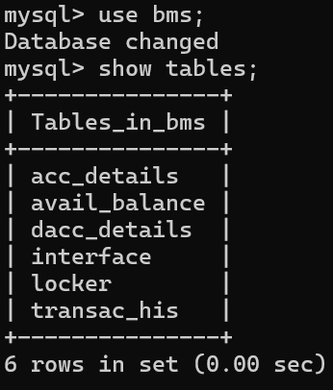

INTERFACE TABLE:
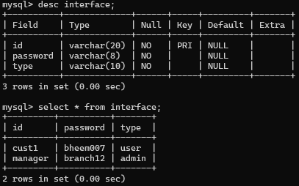
ACCOUNTS TABLE:
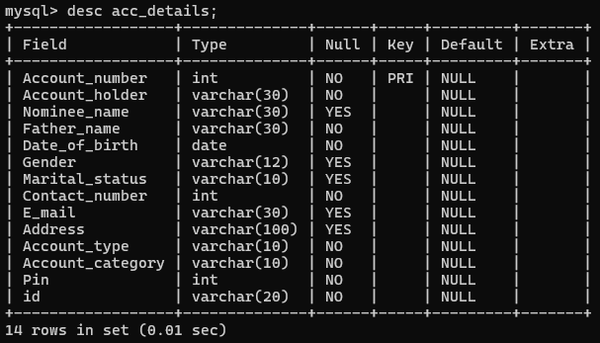

AVAILABLE BALANCE TABLE:
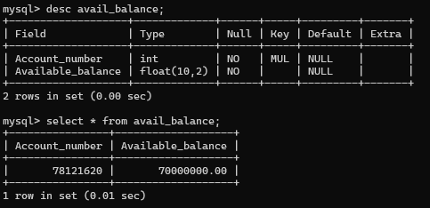
LOCKER TABLE:
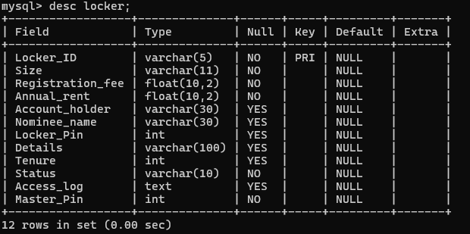

TRANSACTION HISTORY TABLE:
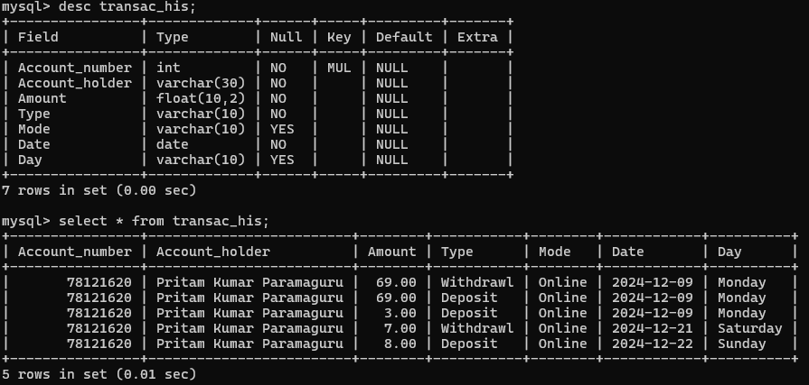
DELETED ACCOUNTS TABLE:
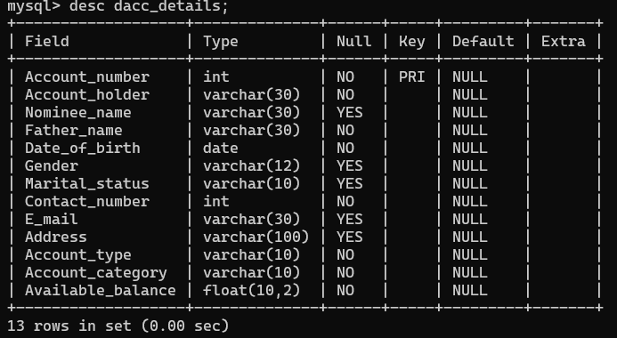

STARTING INTERFACE:

ADMIN AUTHENTICATION:
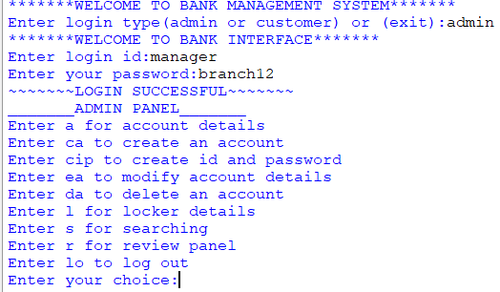

ACCOUNT DETAILS OF ALL CUSTOMERS:
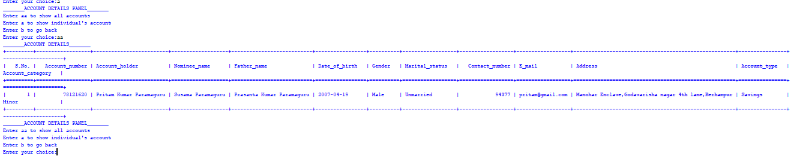

ACCOUNT DETAILS OF EACH CUSTOMER:
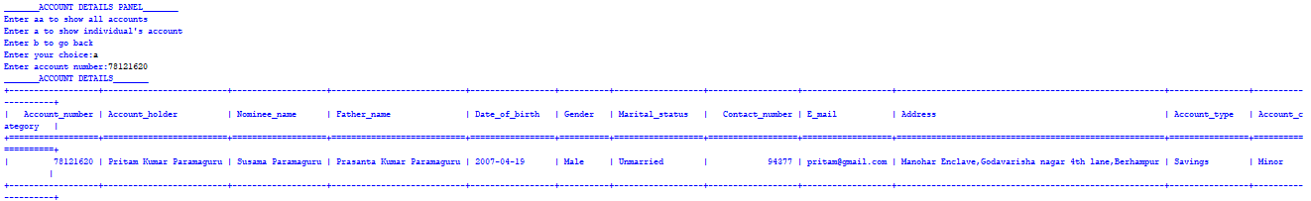

MODIFY ACCOUNT DETAILS:
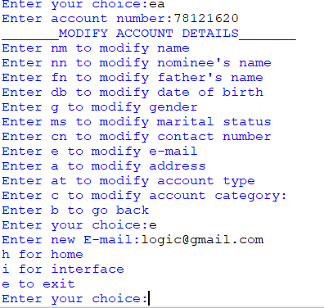

SEARCHING CUSTOMER
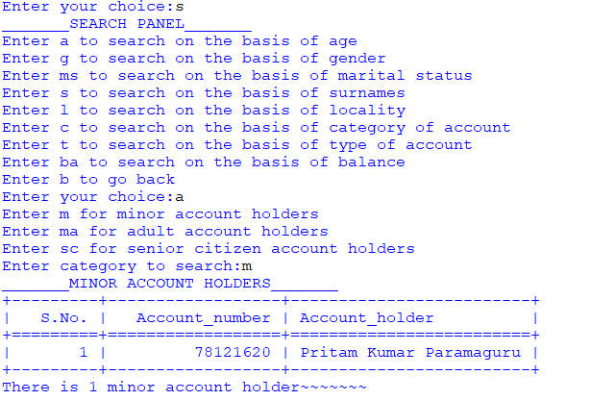
CUSTOMER AUHTHENTICATION:
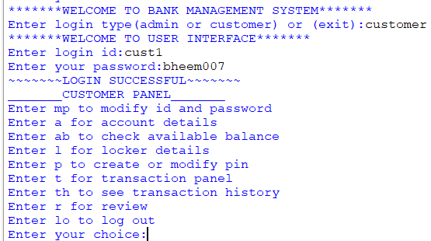

ACCOUNT DETAILS:
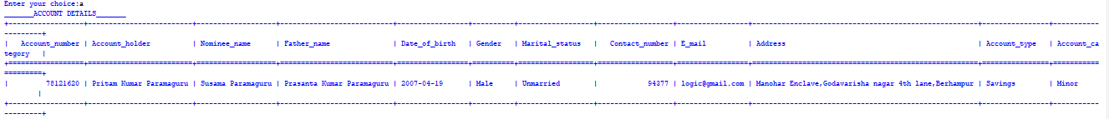

AVAILABLE BALANCE:
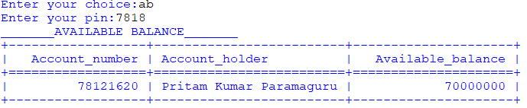
MORE DETAILS ABOUT LOCKER:
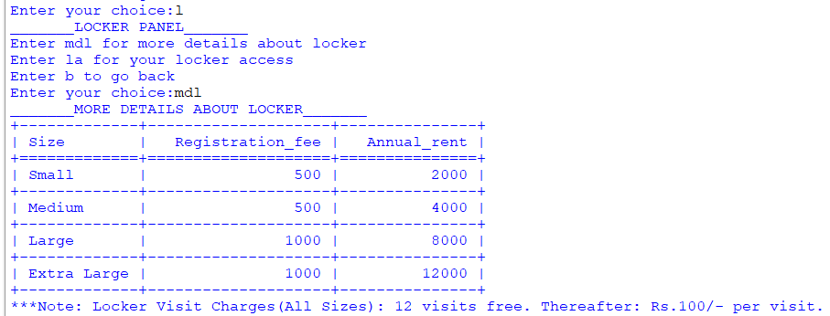

LAST 5 TRANSACTIONS:
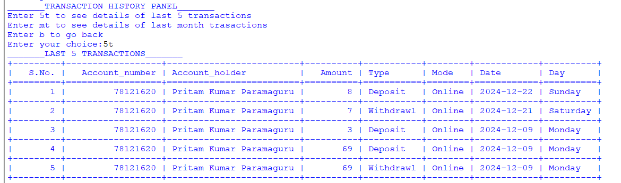

LAST MONTH TRANSACTIONS:
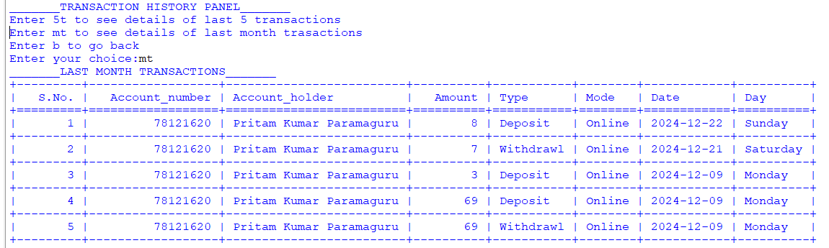
REVIEW PANEL:
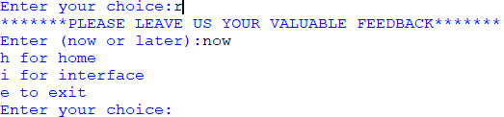
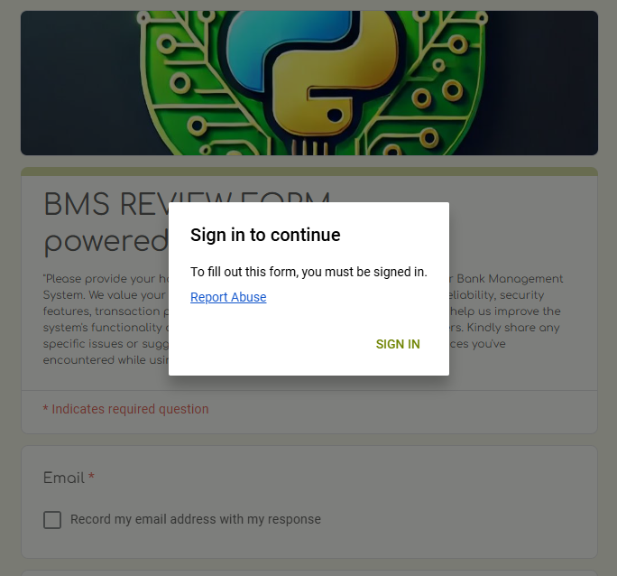

REFERENCES

In order to work on this project titled – LogicLeaf Bank Management System the following books and websites are referred by me during the various phases of development of the project.

- Computer Science with Python (SUMITA ARORA)
- https://docs.python.org/
- https://www.mysql.com/
- https://docs.google.com/forms/
- https://www.geeksforgeeks.org/
- https://www.datacamp.com/
- https://www.w3schools.com/
- https://www.stackoverflow.com/

Other than above mentioned books, the suggestions and supervision of my teacher and my class experience also helped me to develop this software project.

